**TERRAFORM**

**Building Cloud Infrastructure with Terraform**

**Section 1: Terraform Introduction:**

1. **What is Terraform:**

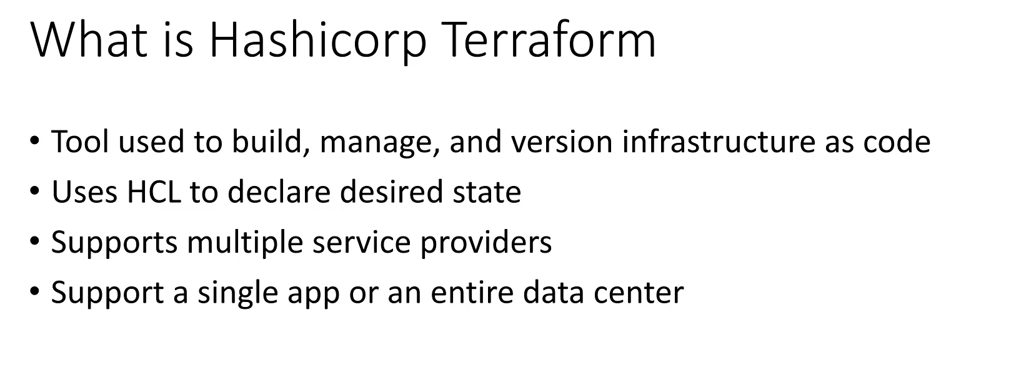

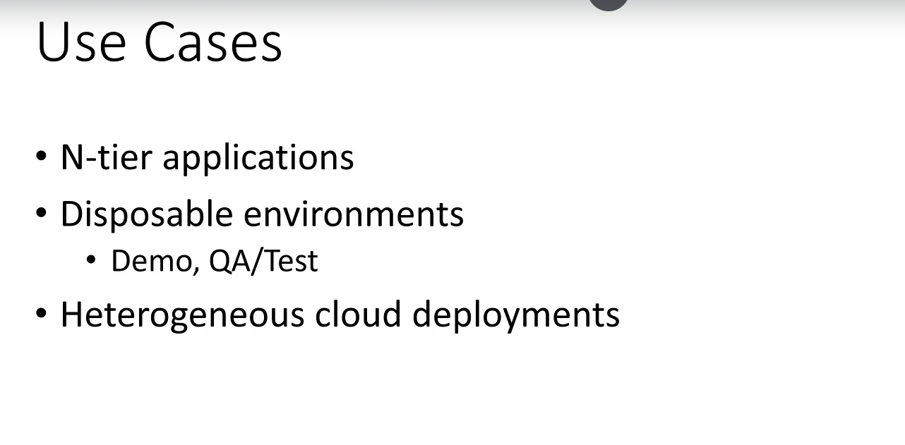

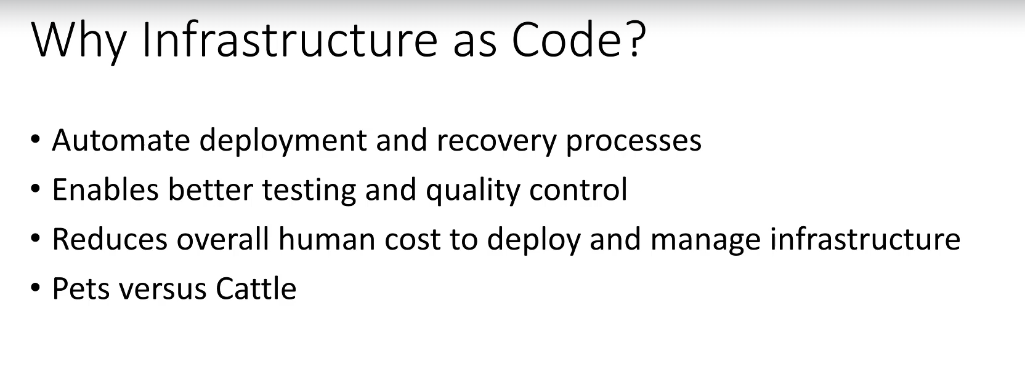

**Summary of Introduction to Terraform and IaC**

**What is Terraform?**

* **Definition:** Terraform is an Infrastructure as Code (IaC) tool created by HashiCorp for building and managing infrastructure safely and efficiently.
* **Declarative Nature:** The code is **declarative**, meaning the user defines the *desired state* of the infrastructure (what it *should* be), and Terraform handles the necessary steps to move the current infrastructure to that desired state.
* **Configuration Language (HCL):** Terraform configurations are primarily written using the **HashiCorp Configuration Language (HCL)**. JSON is also supported, but it is typically reserved for machine-generated code.
* **Platform Agnostic:** Terraform is a cloud and platform-agnostic tool. It supports numerous service providers, including **Azure, Amazon Web Services (AWS), and Google Cloud Platform (GCP)**, along with a long list of others.
  + *Clarification:* This contrasts with provider-specific tools like AWS CloudFormation, which only works with AWS.
* **Scope:** Terraform can be used to provision resources ranging from a simple environment for a single application to an entire virtual data center.
* **Service Types:** It can provision various resource types, including low-level components (VMs, networks, storage) and high-level **PaaS (Platform as a Service)** and **SaaS (Software as a Service)** offerings, provided the service supports a Terraform interface.

**Key Use Cases for Terraform and IaC**

* **Automating N-Tier Applications:** It simplifies the modeling of large, complex architectures, such as traditional three-tier setups (Web/DMZ, Business, Data tiers), which require advanced networking configuration.
* **Disposable Environments:** It enables the rapid creation and destruction of non-persistent environments (e.g., demo, QA, and test) in a matter of minutes, mimicking production with speed.
* **Heterogeneous Cloud Deployments (Multi-Cloud/Hybrid):** Terraform allows the management of infrastructure across multiple cloud providers (e.g., AWS and Azure simultaneously) from a **single codebase**, supporting hybrid or multi-cloud strategies.

**Why Use Infrastructure as Code (IaC)?**

* **Reduced Operational Expense (OpEx) / Cost:** Automating the deployment of VMs, networks, storage, and access lists eliminates the need for manual, time-consuming hand-crafting, reducing human operational costs.
  + *Analogy:* This is referred to as taking a "cattle versus pets" approach, where automated "cattle" are cheaper to manage than manually maintained "pets."
* **Better Quality and Repeatability:** Infrastructure is treated like application code:
  + It can be **tested, scanned, and peer-reviewed** for quality assurance.
  + It can be placed under **Source Control (Version Control)** for tracking changes and collaborative development.
  + It ensures a **consistent and repeatable process** for deployment every time.
* **Increased Agility and Speed:** Automating deployment using Terraform significantly **reduces the time to deploy** infrastructure compared to manual processes.

******************************************************************************************************************************************************************************************************************************************************************************************

**Section 2: Getting started with Terraform:**

1. **Getting started with Terraform:**

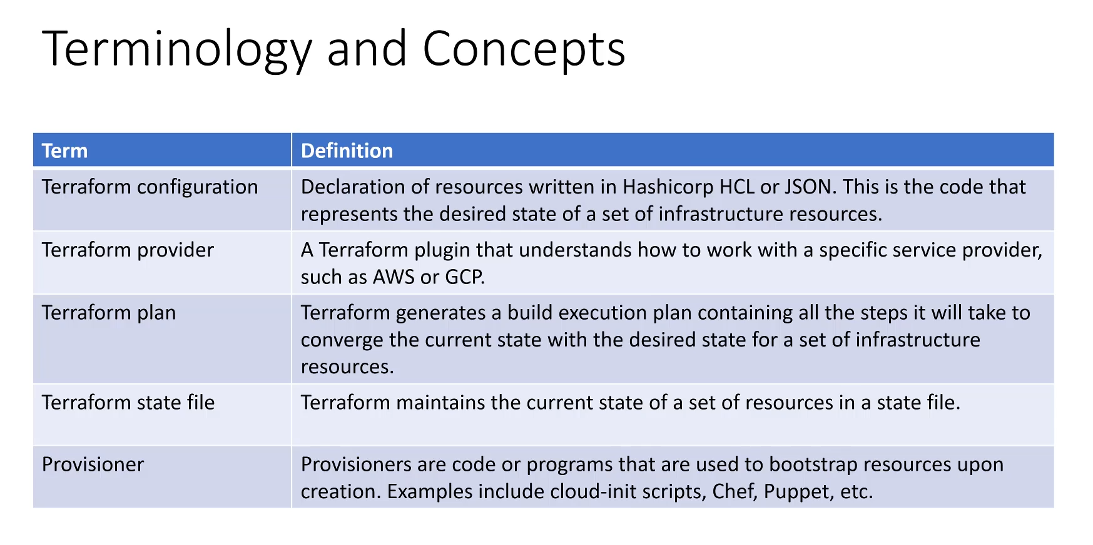

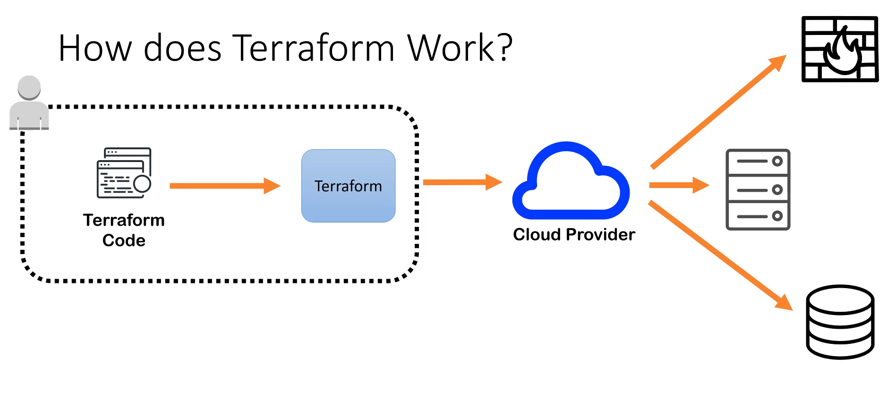

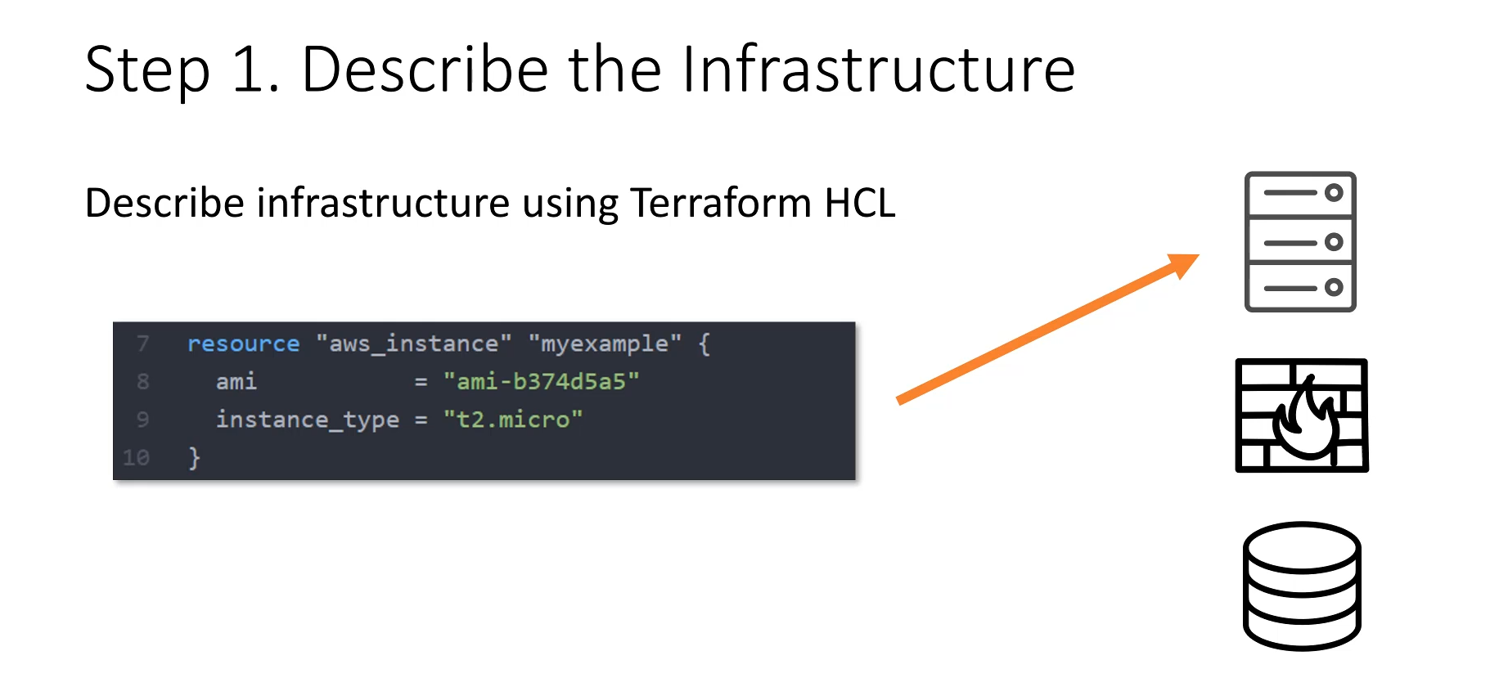

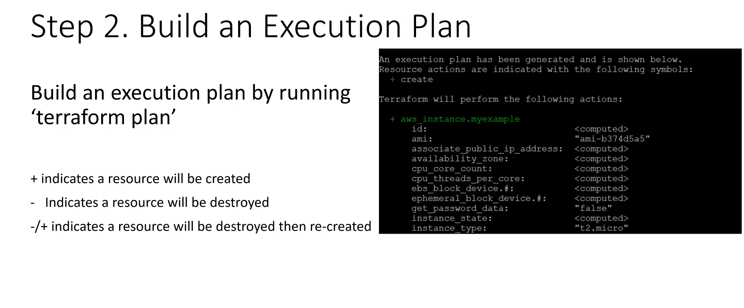

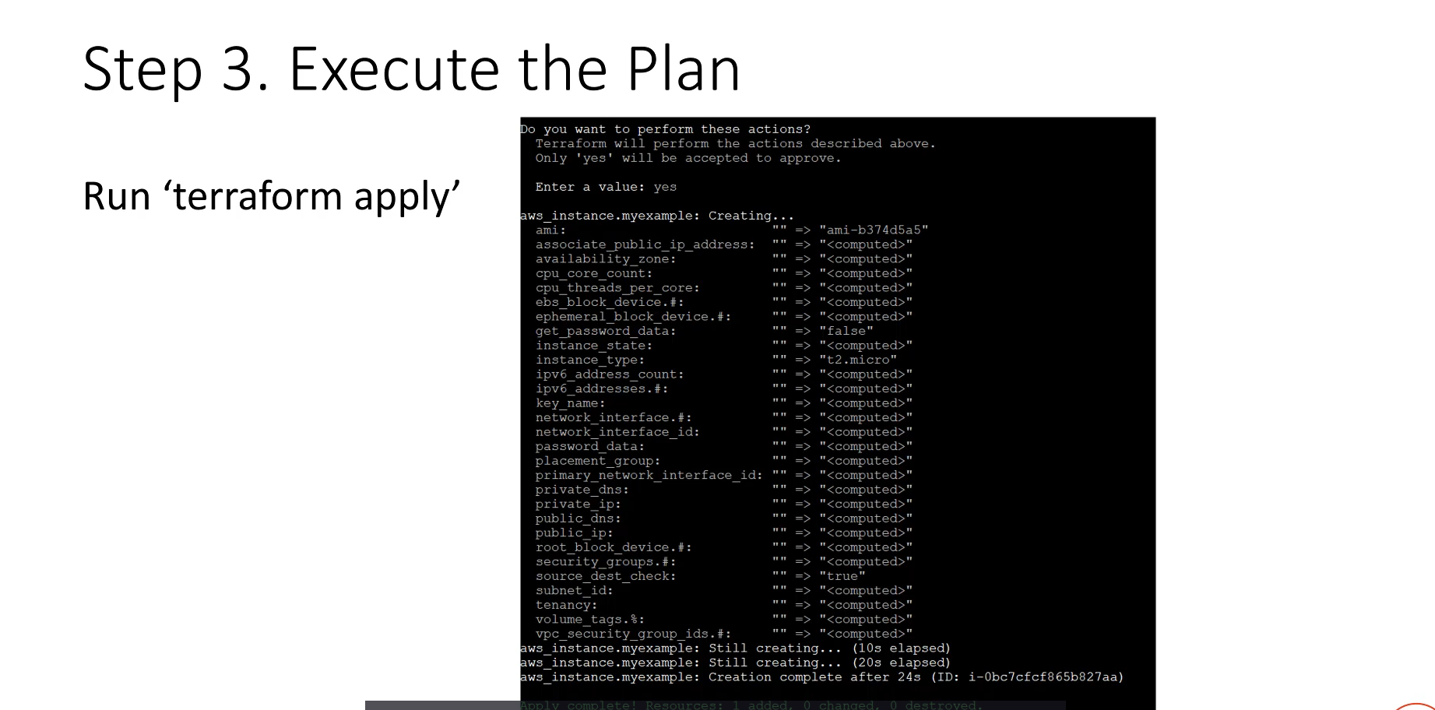

**Core Terraform Terminology and Concepts**

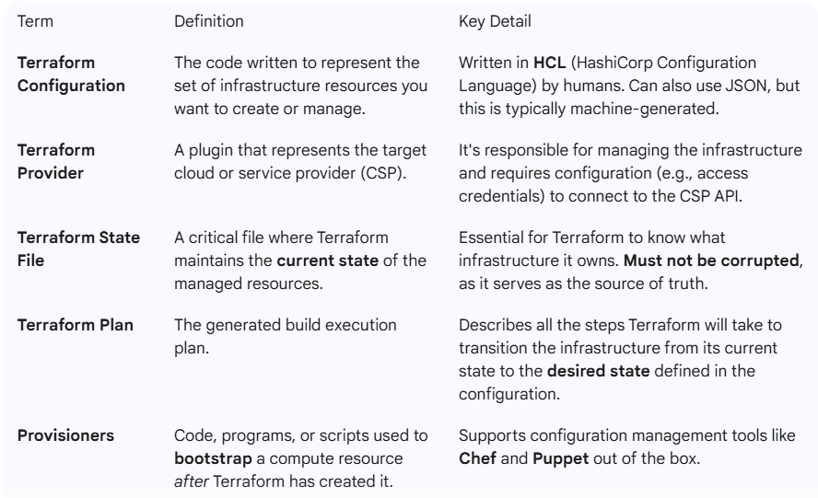

**High-Level Terraform Workflow**

Terraform is a simple, single binary command-line tool that executes the code you write. The typical workflow is as follows:

**1. Describe the Infrastructure (Write Code)**

* **Action:** Write the Terraform code (using HCL) to define the desired state of your infrastructure (e.g., a VM, a storage bucket).
* **Key Principle (Desired State):** You only describe the final desired state. Terraform handles the logic of moving from the present state to the new state.
  + *Example:* To change a VM's size, you simply edit the instance_type in the code. Terraform figures out how to apply the change (e.g., modify in place or destroy/recreate).
* **Configuration Blocks:** The code includes resource blocks (e.g., resource "aws_instance" "my_example") and the required **Provider configuration** to connect to the cloud provider (like AWS, Azure, etc.).

**2. Build an Execution Plan**

* **Command:** Run terraform plan.
* **Function:** Terraform compares the **current state** (from the state file) with the **desired state** (from the configuration) to generate a detailed plan of changes.
* **Plan Indicators:** The plan uses symbols to indicate the planned action for each resource:
  + **+ (Green):** The resource will be **created**.
  + **- (Red):** The resource will be **destroyed**.
  + **- / + (Destroy then Create):** The resource will be **destroyed and recreated**. This occurs when a resource property cannot be modified in-place (e.g., changing the base Machine Image/OS).

**3. Execute the Plan**

* **Command:** Run terraform apply.
* **Function:** This command executes the steps outlined in the execution plan to create, modify, or destroy resources, converging the infrastructure to match the desired state defined in your code.
* **Result:** The physical infrastructure is provisioned or changed, and the **state file** is updated to reflect the new current state.

===================================================================================

1. **Coding with Terraform:**

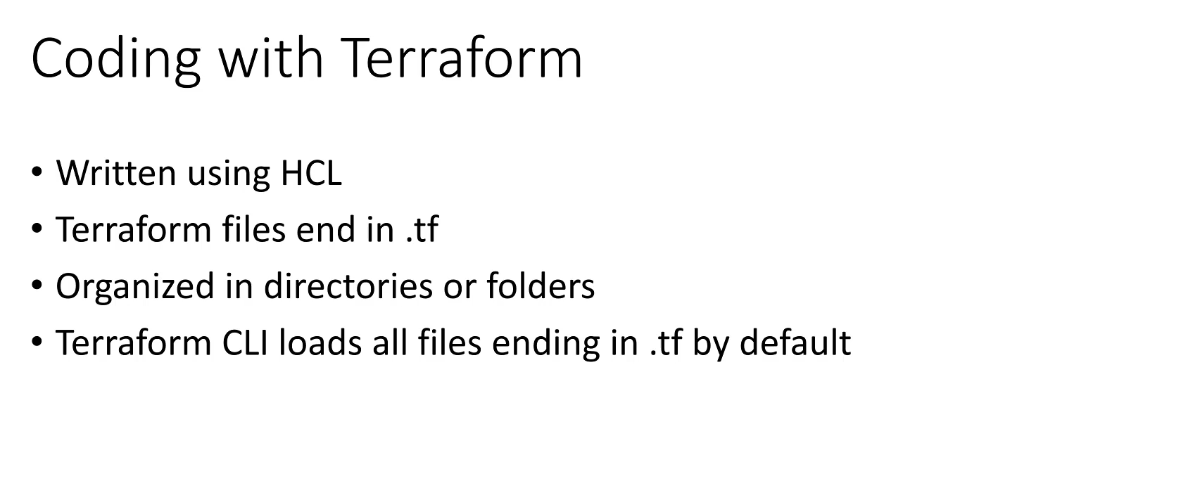

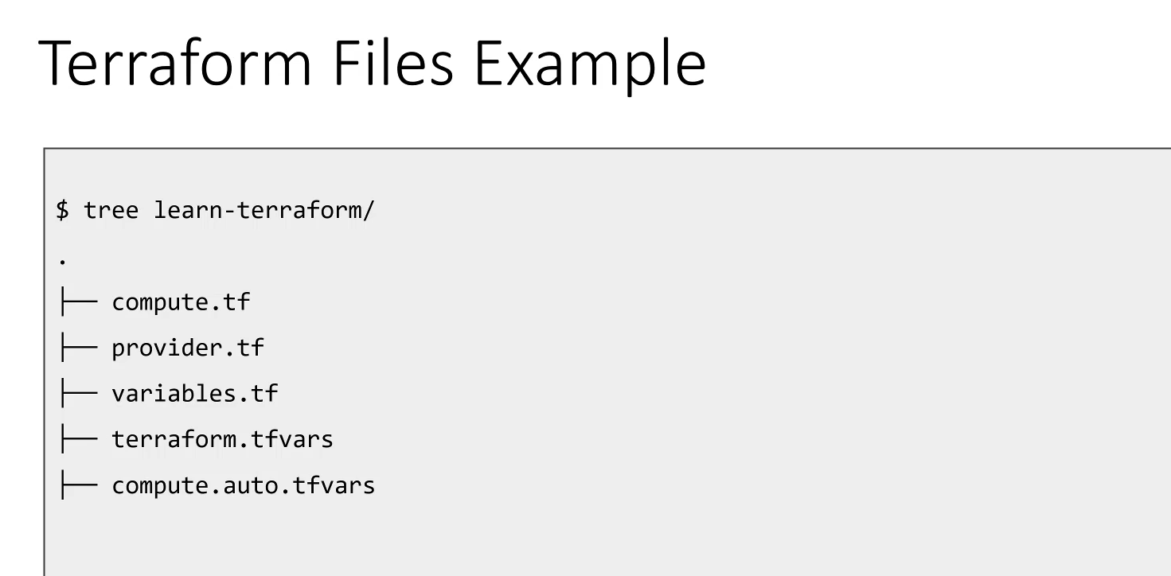

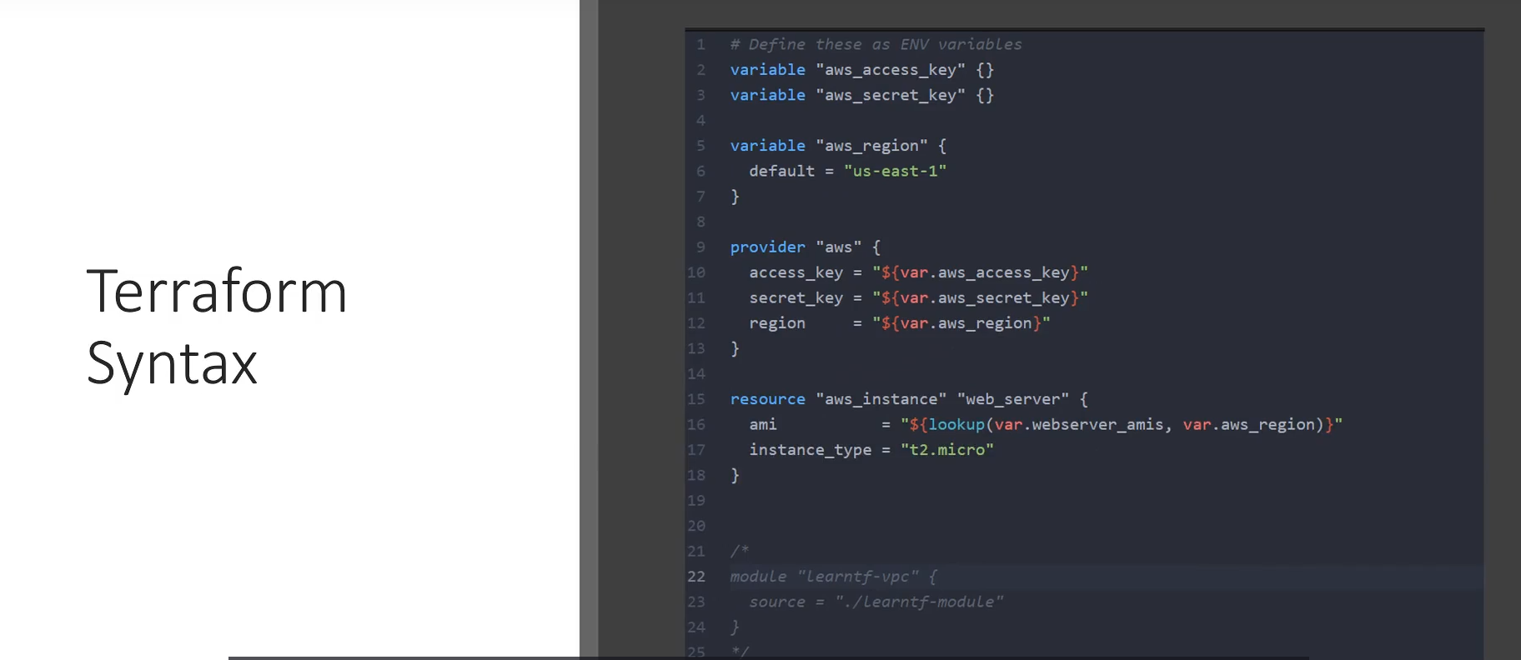

**Terraform Coding Fundamentals**

**File Organization and Naming Conventions**

* **File Extension:** All Terraform configuration files must end with the **.tf** extension (e.g., compute.tf, provider.tf).
* **Structure:** Terraform files are organized into **directories or folders**. Related groups of resources (a "project") should be kept together in a single directory.
* **Automatic Loading:** When you run any core Terraform CLI command (like terraform plan, apply, or destroy), the tool automatically loads and processes **all files** ending in .tf within the current directory.
* **Special Variable Files:** Terraform also automatically loads and processes specific files reserved for variable assignments:
  + Files ending in **.tfvars**.
  + Files named **terraform.tfvars** and **\*.auto.tfvars**. These files typically contain variable assignments and are automatically processed without being explicitly specified.

**Basic HCL (HashiCorp Configuration Language) Syntax**

* **Comments:**
  + **Single-line comments** start with a **hashtag (#)**.
  + **Multi-line comments** are supported using the C-style syntax: **/* ... */**.
* **Value Assignment:** Values are assigned using the **key = value** structure.
* **Data Types:** Values can be various data types, including:
  + **String** (e.g., "us-west-2")
  + **Number** (e.g., 8080)
  + **Boolean** (e.g., true)
  + **List** (e.g., ["a", "b"])
  + **Map** (e.g., { key = "value" })
* **Whitespace:** Terraform **ignores whitespace**. Adding spaces around the equal sign (key = value) is a stylistic choice for better readability.
* **Strings:** All **string values must be enclosed in double quotes (")**. Single quotes are not used for strings in HCL.

===================================================================================

1. **Terraform Syntax:**

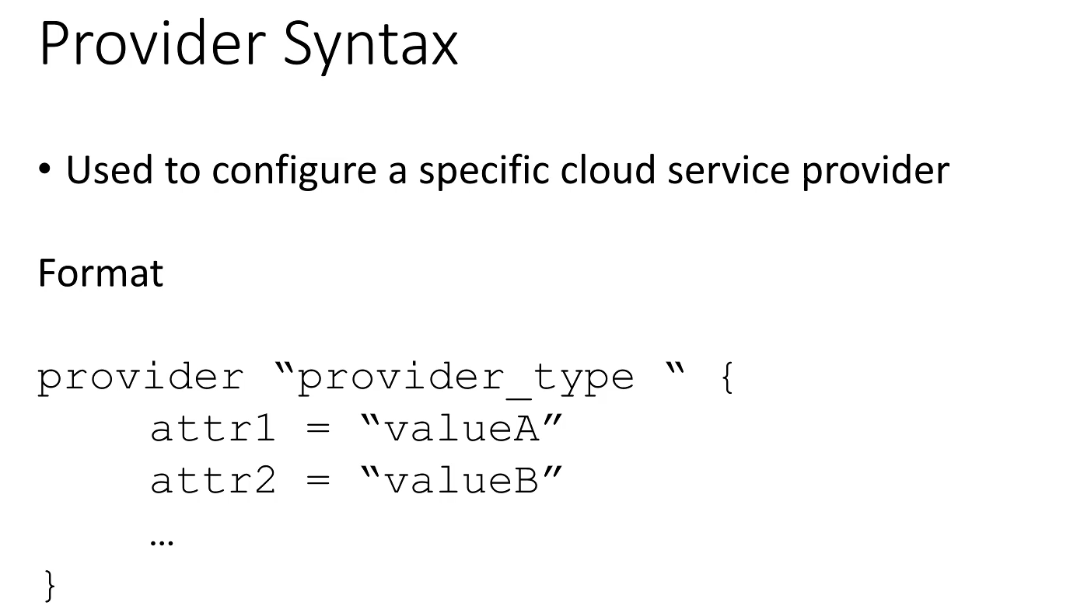

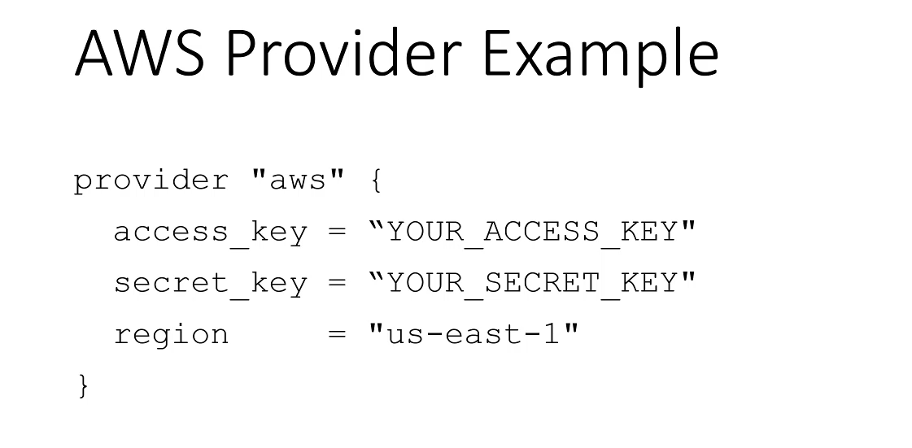

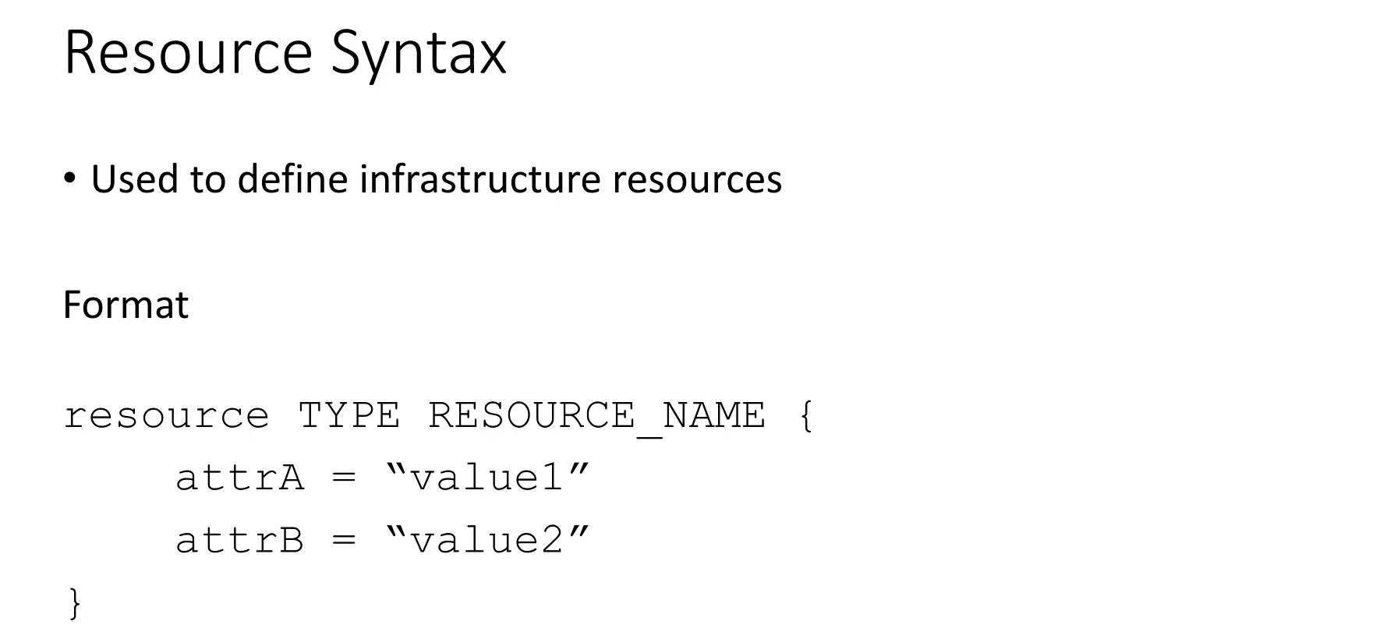

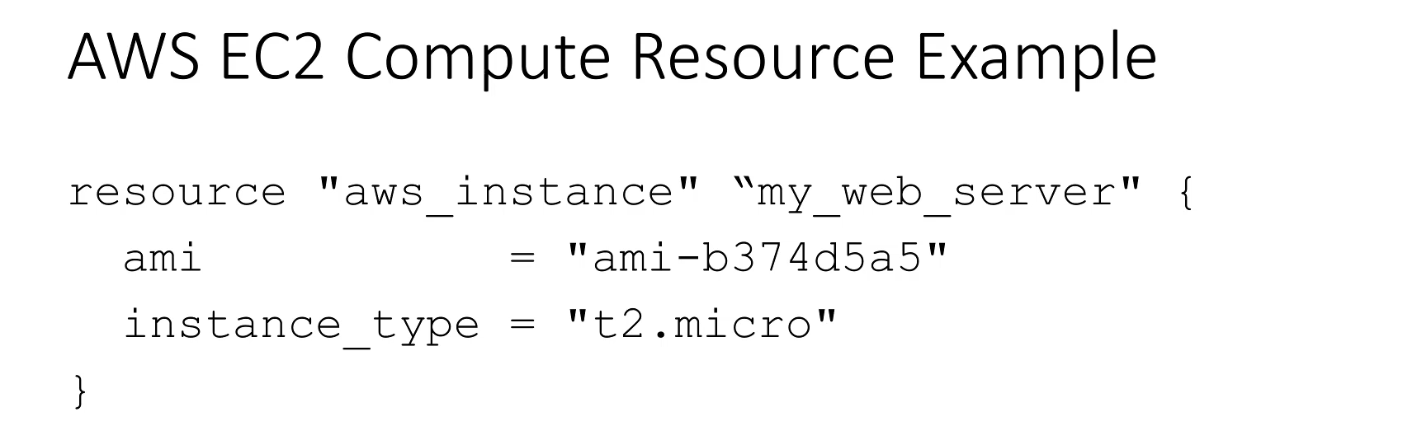

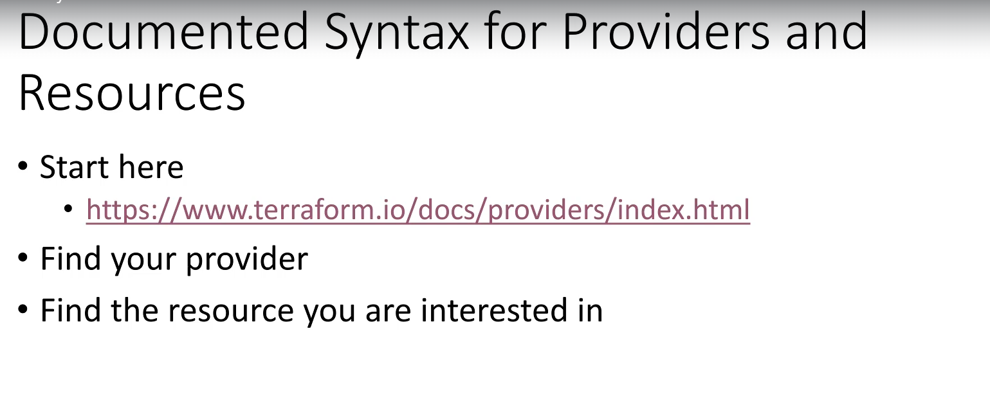

**Fundamental Configuration Syntax**

**1. Provider Configuration**

The **provider** configuration is essential as it defines the cloud service provider (CSP) Terraform will interact with, acting as a specialized plugin.

**Syntax:**

provider "PROVIDER_TYPE" {

# key-value pairs specific to the provider

}

* **Keywords:**
  + provider: The mandatory keyword to start the block.
  + PROVIDER_TYPE: The unique, reserved keyword for the provider (e.g., **aws**, **gcp**, **azure**).
* **Attributes (Inside Braces):** The content inside the curly braces contains key-value pairs used to configure the connection.
  + *Example (AWS):* Includes the **access_key**, **secret_key**, and **region** (specifying where resources will be created, such as us-east-1). These attributes are unique to each provider.

**2. Resource Configuration**

The **resource** configuration is the most frequently used block and represents a single component of infrastructure you wish to create (e.g., a compute instance, a storage bucket, a network subnet).

**Syntax:**

resource "RESOURCE_TYPE" "RESOURCE_NAME" {

# required and optional attributes for the resource

}

• **Keywords:**

* resource: The mandatory keyword to start the block.
* RESOURCE_TYPE: The type of resource, which is **specific to the provider** (e.g., aws_instance, azurerm_virtual_network).
* RESOURCE_NAME: An **arbitrary name** you choose. This name is used as a reference for other resources throughout your Terraform code.

• **Attributes (Inside Braces):** These are the required and optional parameters that define the resource's properties.

* *Example (AWS Instance):* Requires **ami** (the machine image to load) and **instance_type** (the VM shape/size, like t2.micro). The required attributes differ based on the resource type.

**Documentation and Lab Prerequisites**

**Terraform Documentation Reference**

* All supported providers, resources, and data sources are thoroughly documented on the official **Terraform website** (under the Providers section).
* The documentation is critical for finding the exact RESOURCE_TYPE and determining which attributes are **required** and which are **optional** for any given resource (e.g., checking the "Argument Reference" for aws_instance).

**Lab Prerequisites and Liability**

To begin building real infrastructure, you must complete the following steps:

1. **Obtain an AWS Account:** An AWS account is required to perform the upcoming labs.
2. **Install Terraform:** Download and install the Terraform single binary.
3. **Liability and Free Tier:**
   * The student is **liable for any charges** incurred from the cloud service provider during the labs.
   * It is highly recommended to use the **AWS Free Tier** account, which offers 12 months free usage of specific resources.
   * To avoid charges, it is crucial to **destroy all resources** at the end of every lab, as the free tier limits are sufficient only if resources are not left running.

===================================================================================

1. Creating our first instance:

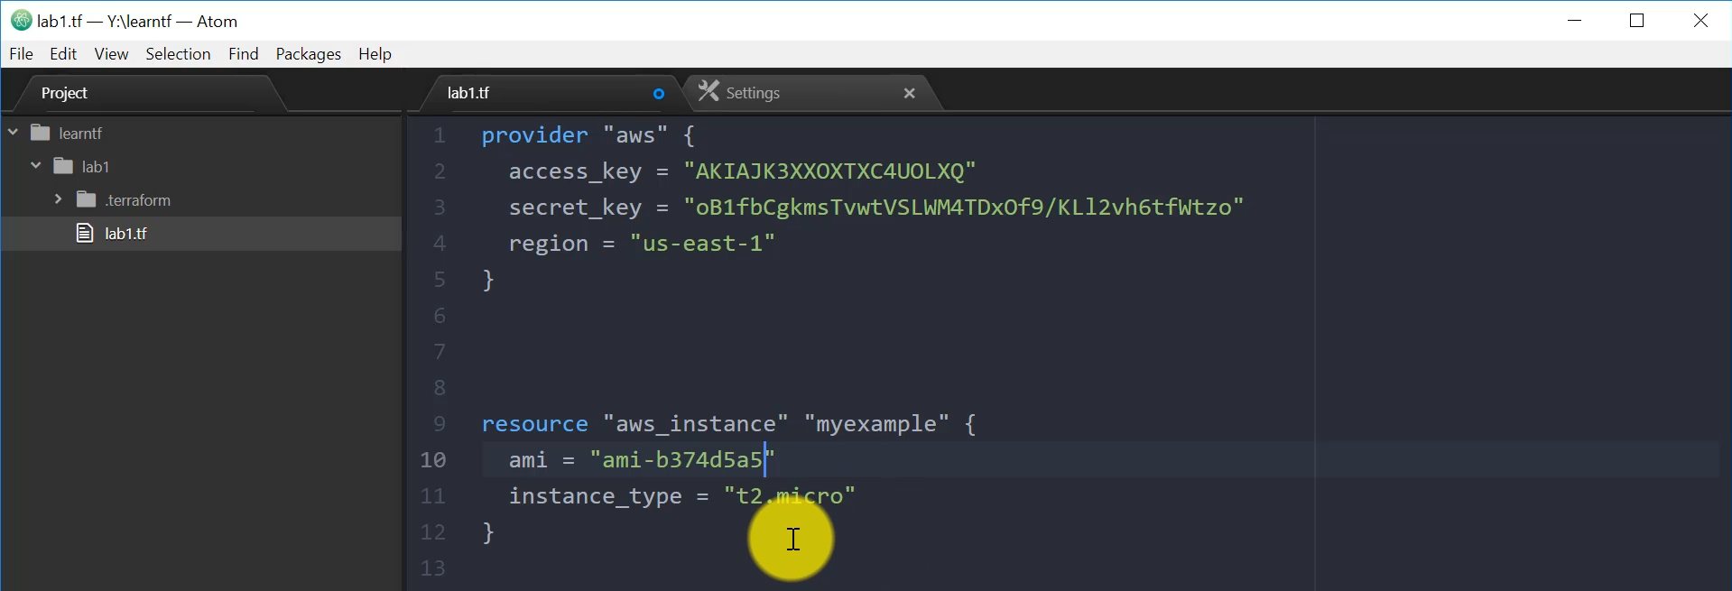

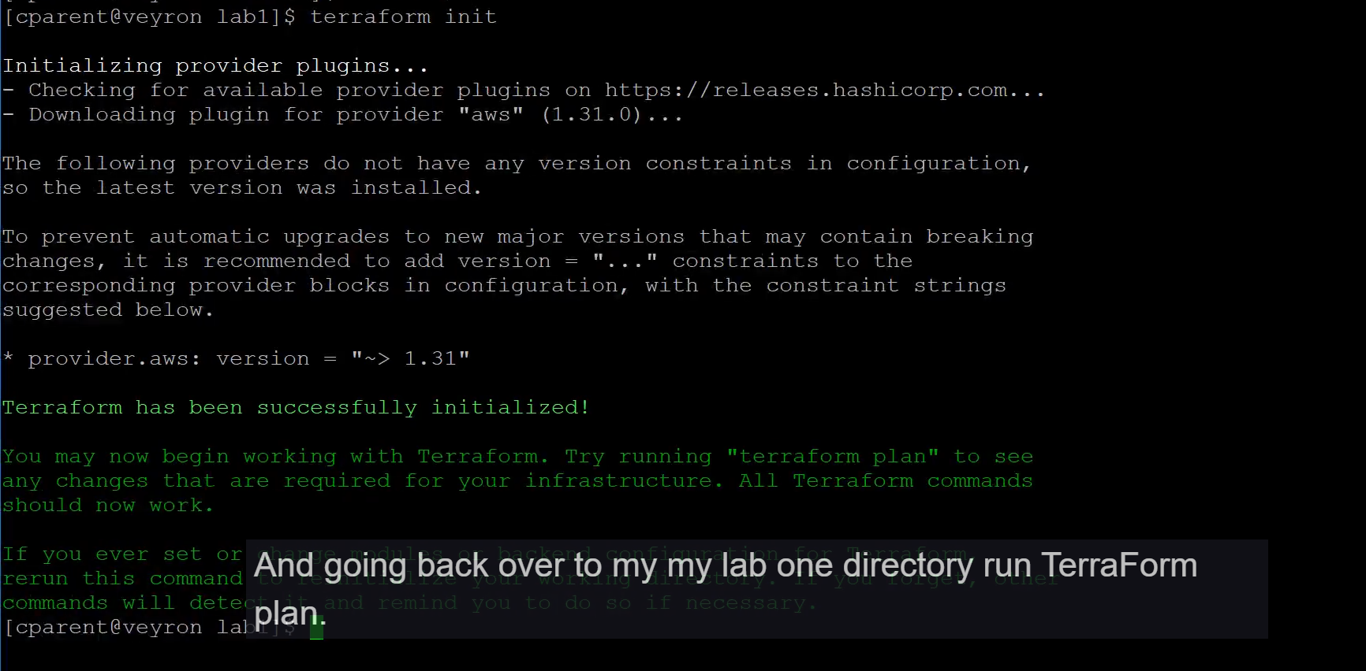

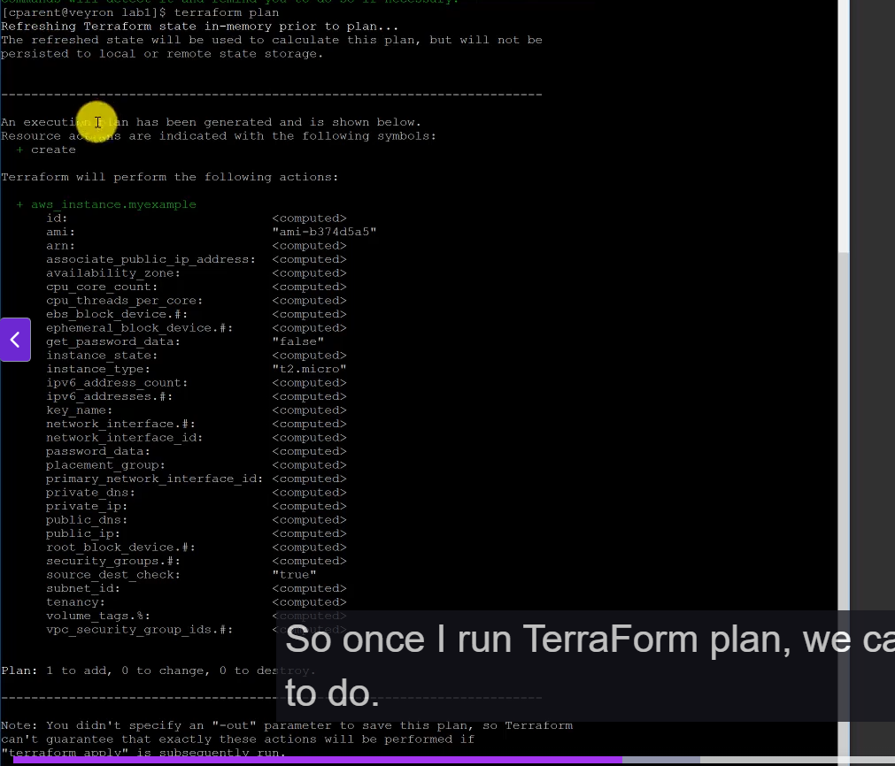

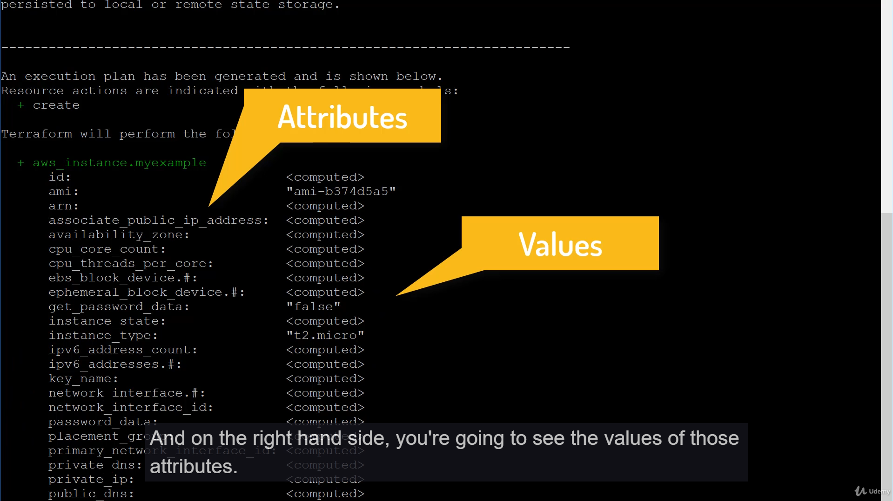

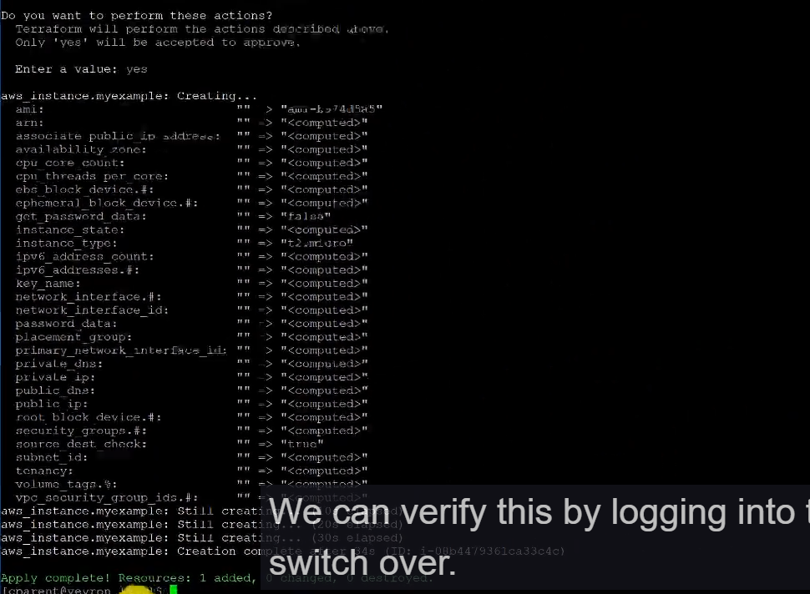

===================================================================================

1. Change a Resources:

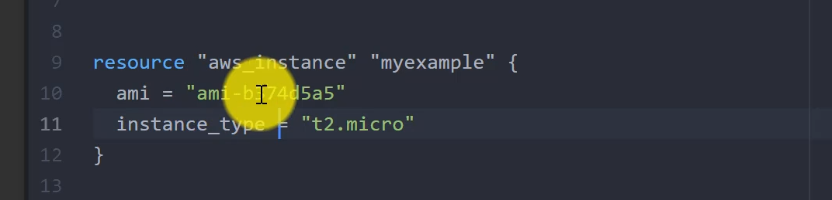

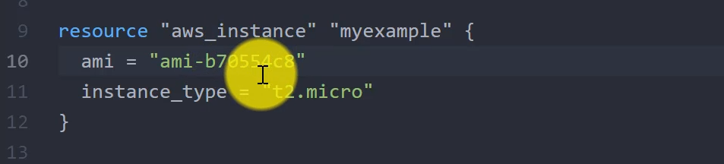

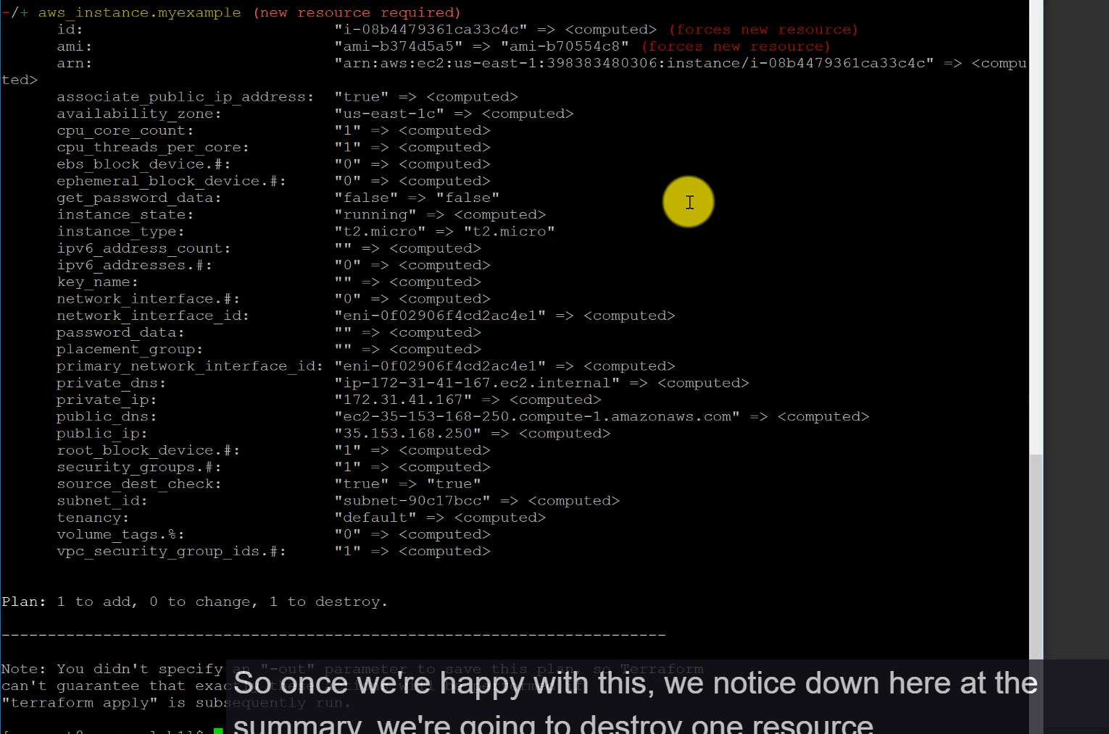

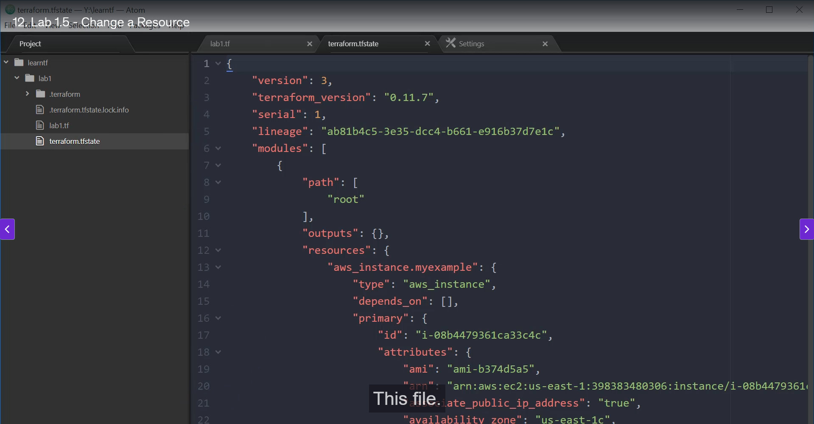

===================================================================================

1. Destroy a resource:

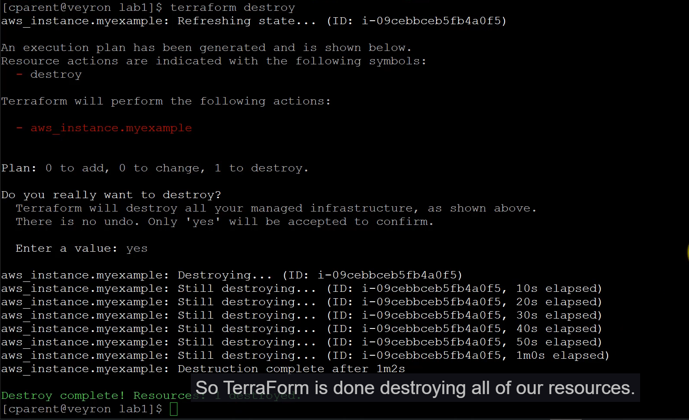

******************************************************************************************************************************************************************************************************************************************************************************************

**Section 2: Terraform Variable and Interpolations:**

* 1. Terraform Variable:

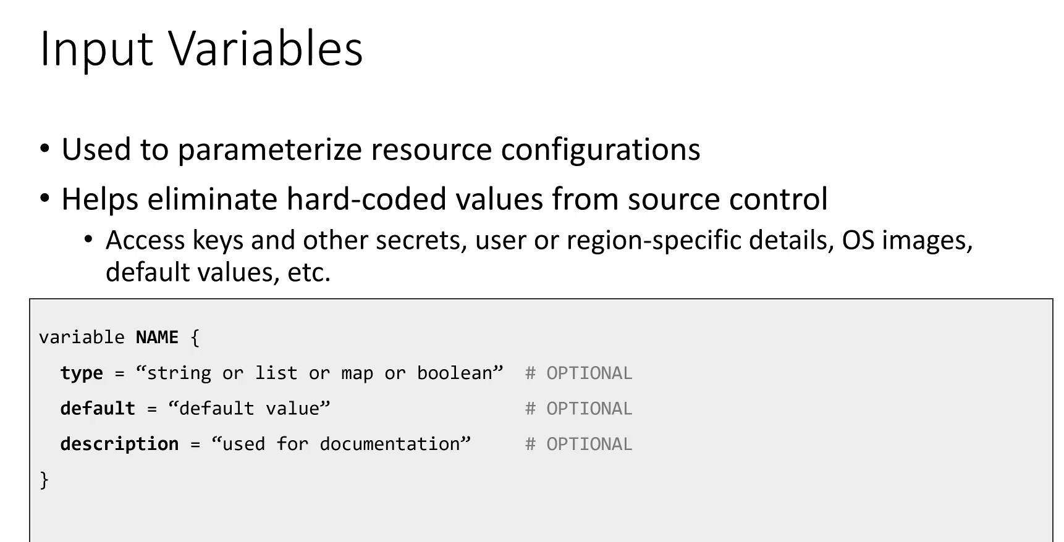

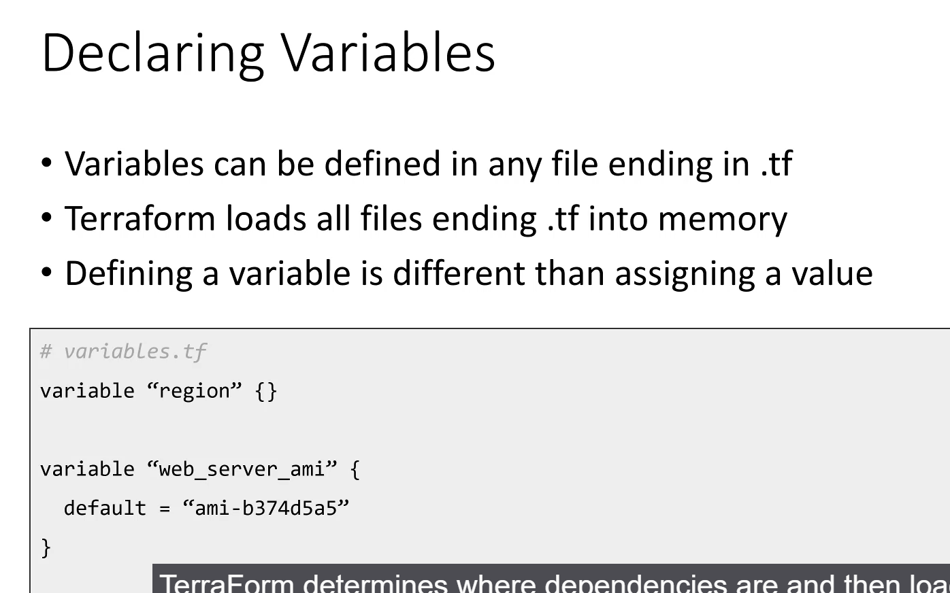

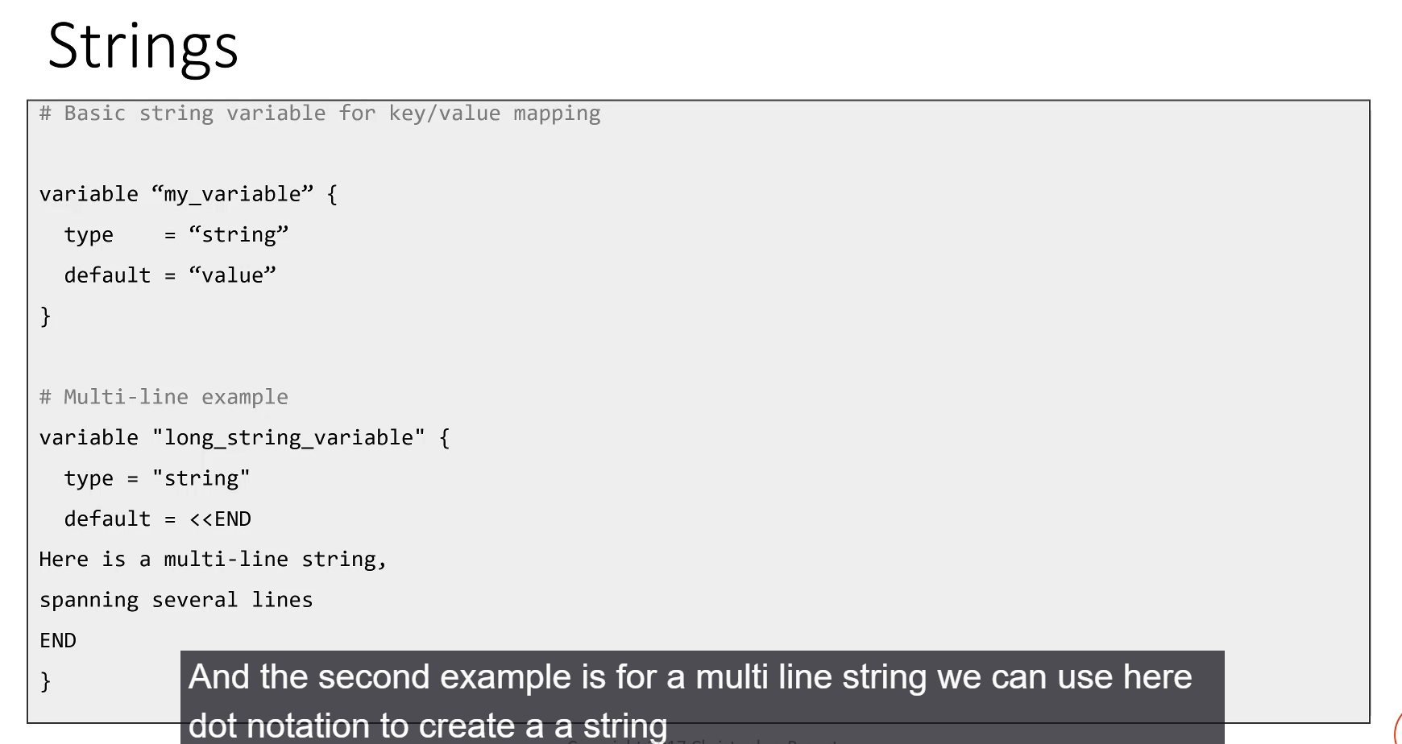

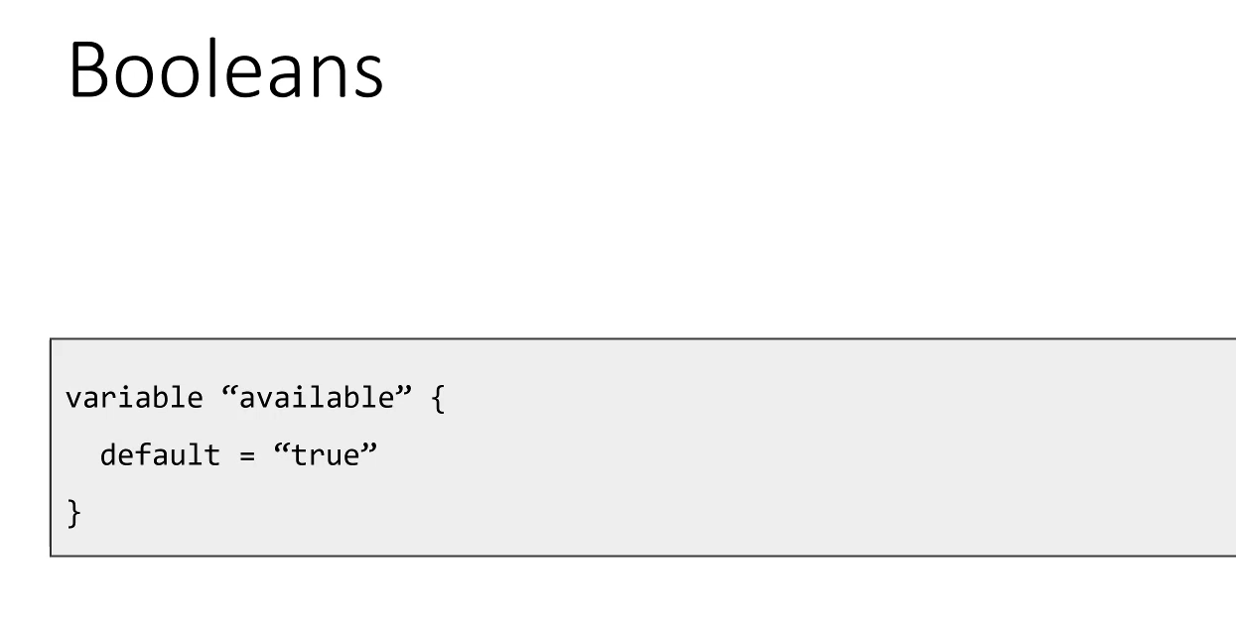

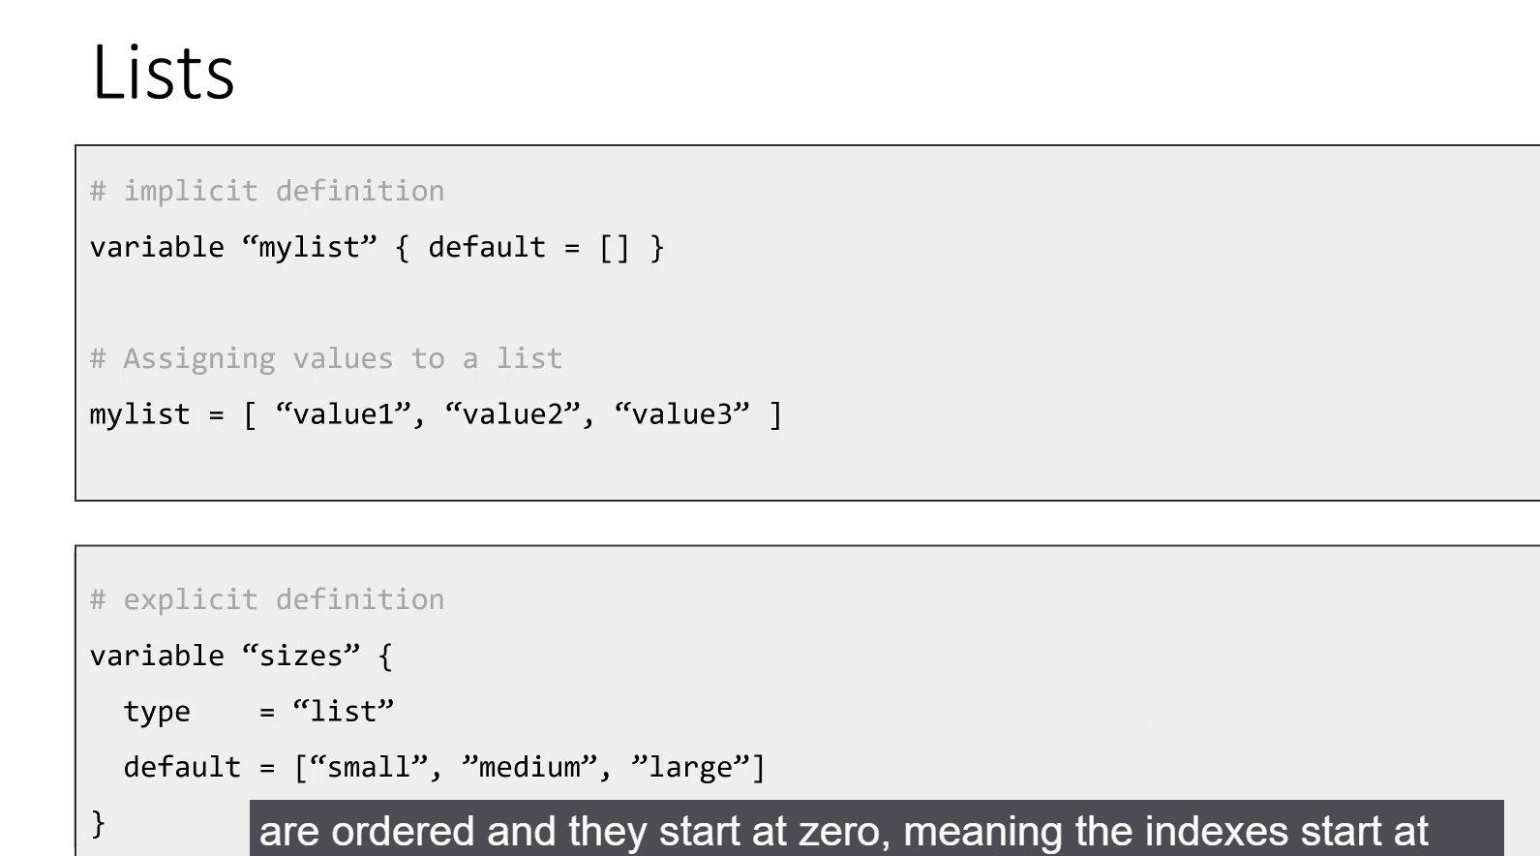

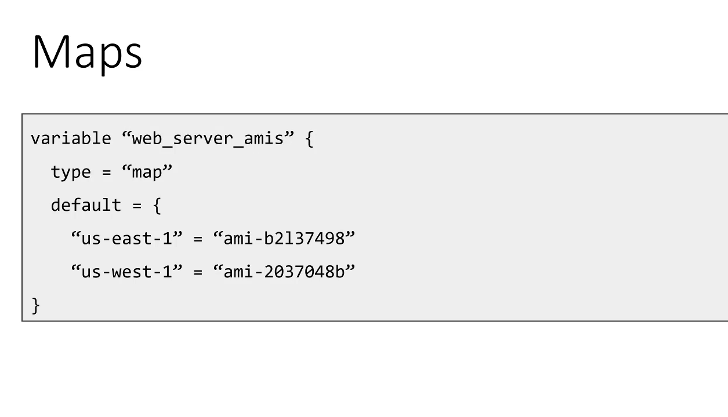

**TerraForm Variables: Input Variables**

**1. Purpose and Importance**

* **Parameterization:** Input variables are used to **parameterize** your Terraform configuration, effectively decoupling hardcoded values from your resource definitions.
* **Flexibility and Versatility:** This design makes the code more versatile. For instance, instead of hardcoding an AWS Region and AMI, you can use a variable, allowing you to deploy the **same infrastructure** to different regions without maintaining multiple configuration files.
* **Decoupling:** Variable values can be defined and assigned separately—via files, environment variables, or the command line—decoupling specific configuration details from the resource code.

**2. Variable Declaration Syntax**

All variables **must be declared** in Terraform using the following general syntax:

variable "NAME" {

# All attributes below are optional

type = string # The data type (default is string)

default = "value" # A default value for the variable

description = "A brief explanation of the variable."

}

• **variable Keyword:** The special keyword used to begin a variable declaration block.

• **NAME:** The name you assign to the variable, which will be used for referencing it.

• **type (Optional):** Specifies the data type (string, number, bool, list, map, object, etc.). The default type is **string**.

• **default (Optional):** Provides a fallback value. If no value is explicitly assigned later, Terraform will use this default.

• **description (Optional):** Used purely for documenting the variable within the code.

**3. Execution Order and Declarative Nature**

* **Load Order:** When running Terraform commands, it loads all .tf files in the current directory into memory.
* **Dependency Graph:** Terraform builds an internal dependency graph of all resources and variables.
* **Declarative, Not Procedural:** Terraform is declarative, meaning the order in which you define variables or resources in the .tf files **does not matter**. Terraform automatically determines and loads dependencies in the correct order.

**Supported Variable Data Types**

Terraform supports several fundamental data types for input variables:

**A. String**

* **Default Type:** Strings are the default type if the type attribute is omitted.
* **Explicit Declaration:** You can explicitly declare a string using type = string.
* **Multi-line Strings:** Supported using **Heredoc syntax** (e.g., <<EOF ... EOF).

**B. Boolean**

* Represents a true or false value.
* *Example:* default = true (Note: Terraform handles the literal keywords true and false as booleans, not strings).

**C. List**

* An **ordered collection** of values (array).
* **Implicit Declaration:** Declaring a default value as an empty list (default = []) makes Terraform assume the type is a list.
* **Explicit Declaration:** Use type = list (e.g., type = list(string)).
* **Indexing:** List indexes start at **zero (0)**.

**D. Map**

* An **unordered collection of key-value pairs** (similar to dictionaries or hash maps in other languages).
* **Lookup:** The key is used to look up and retrieve the associated value.
* *Example:* Can be used to map AWS regions to their corresponding Amazon Machine Images (AMIs).

===================================================================================

* 1. Using Variables:

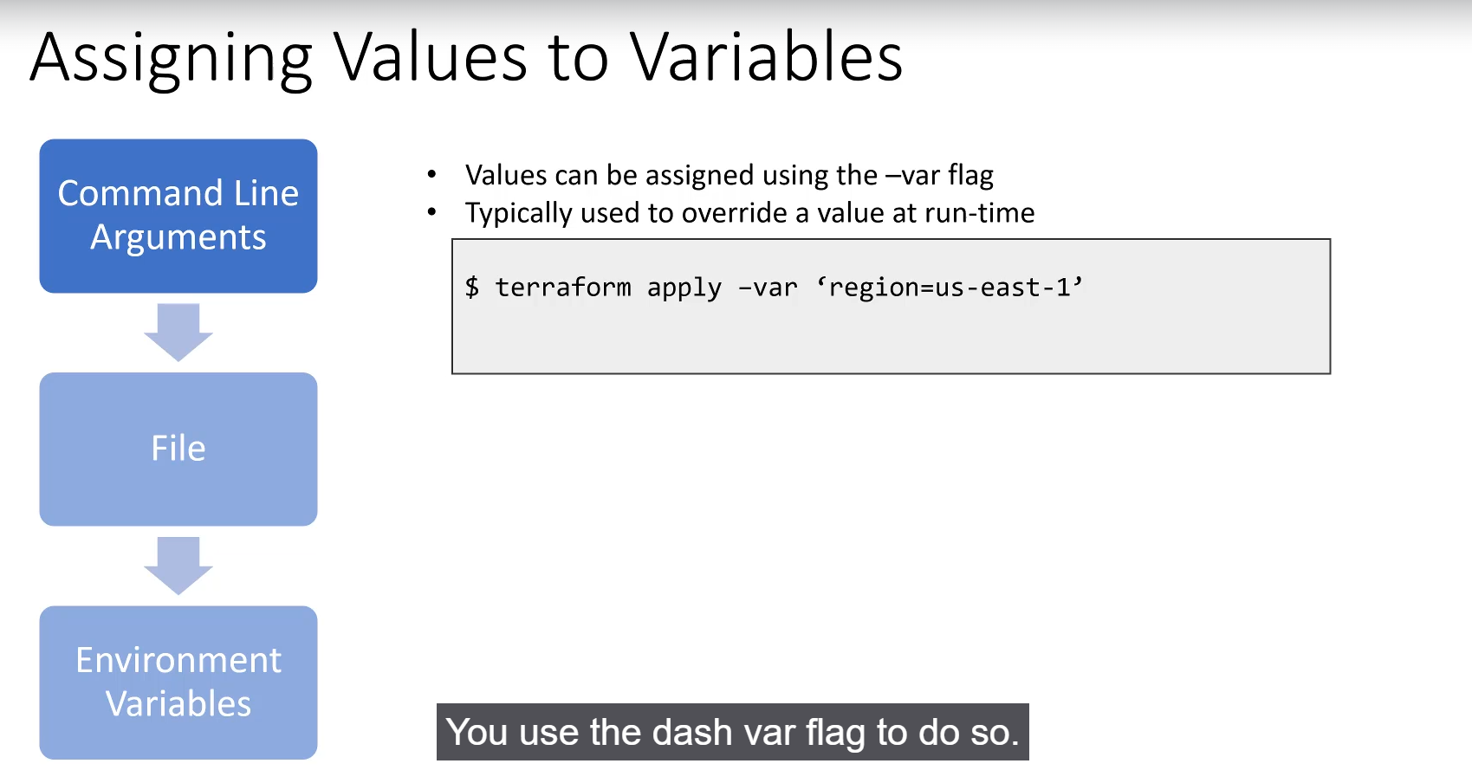

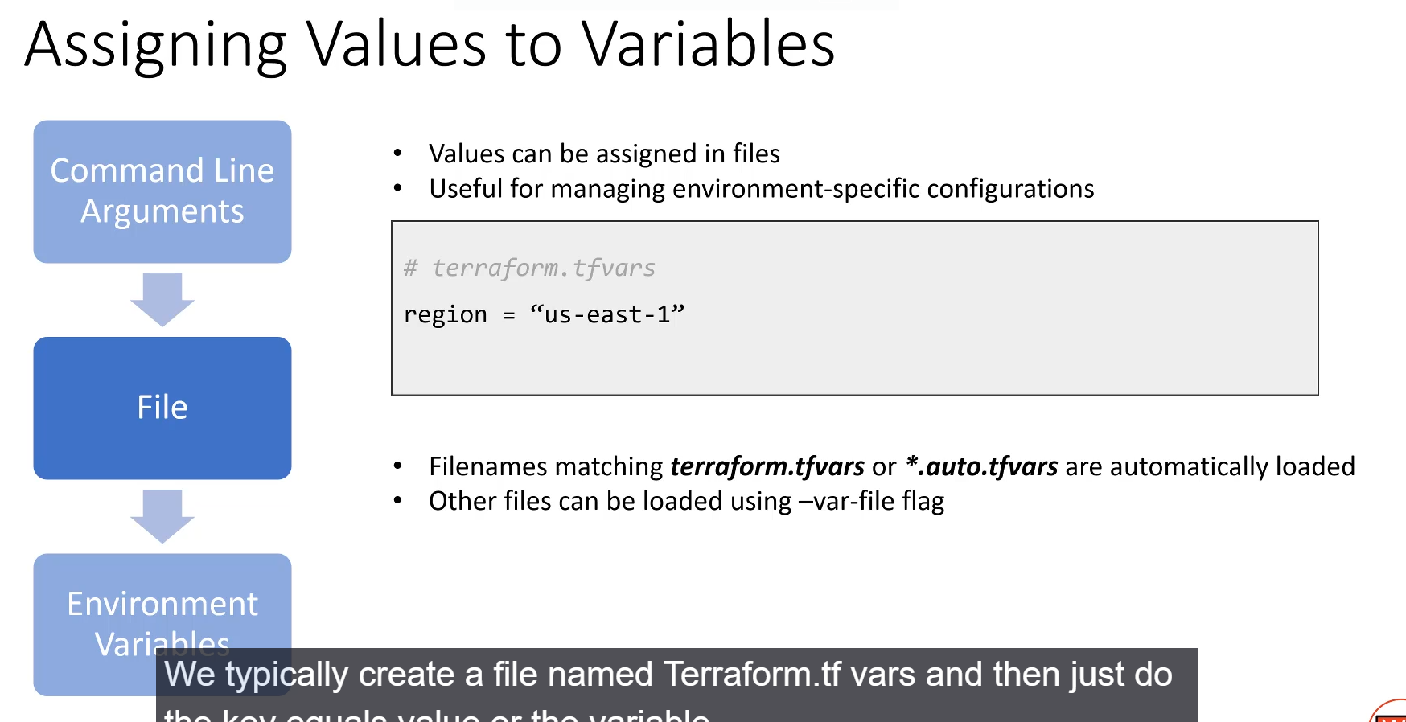

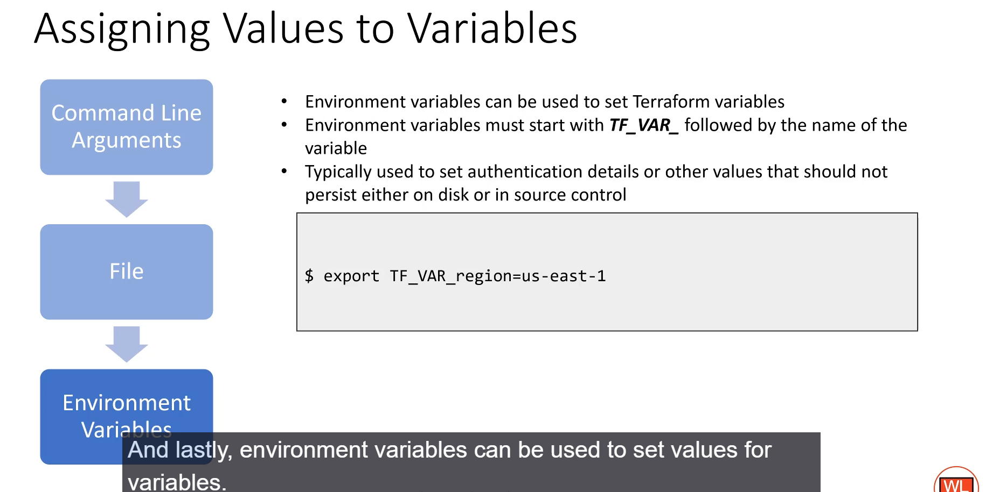

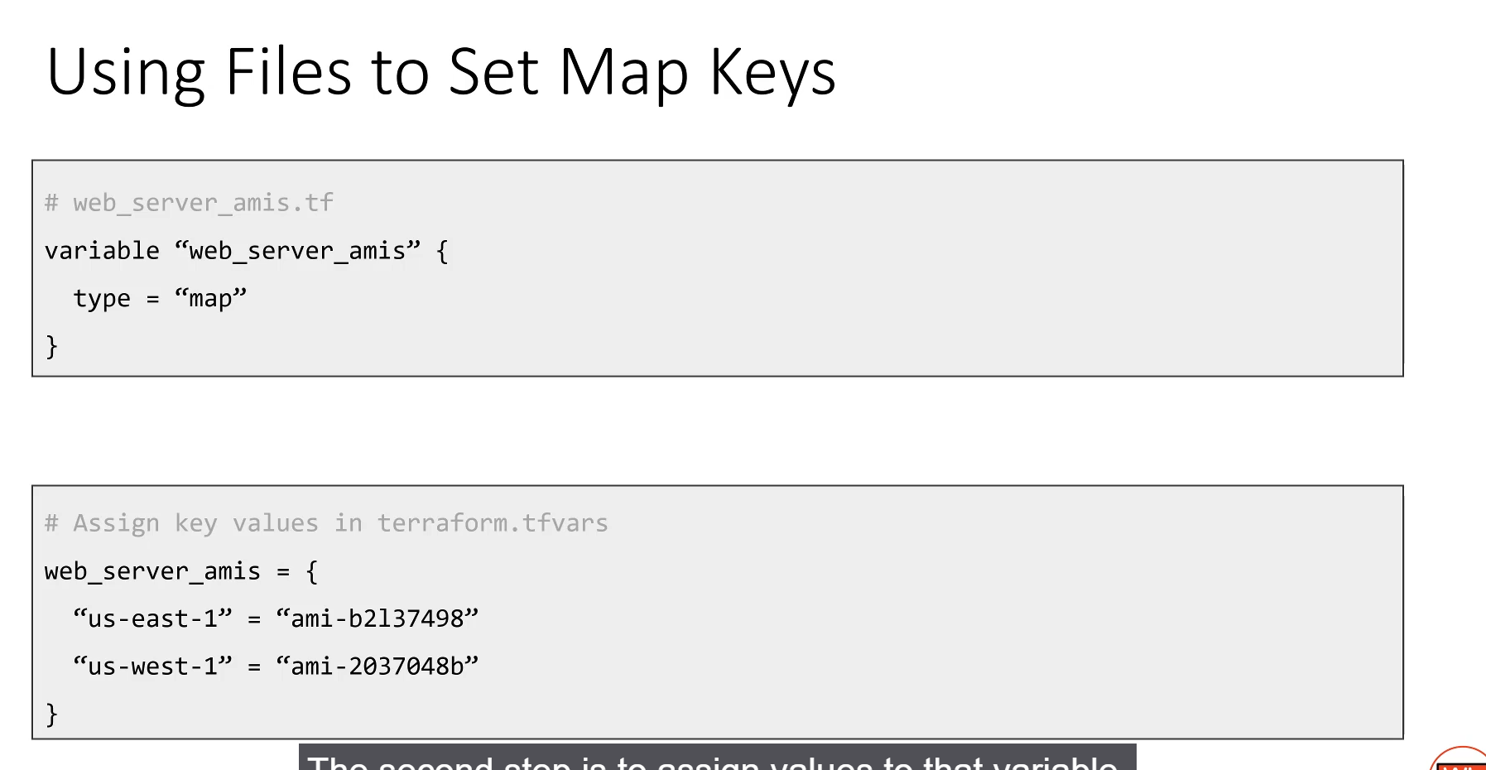

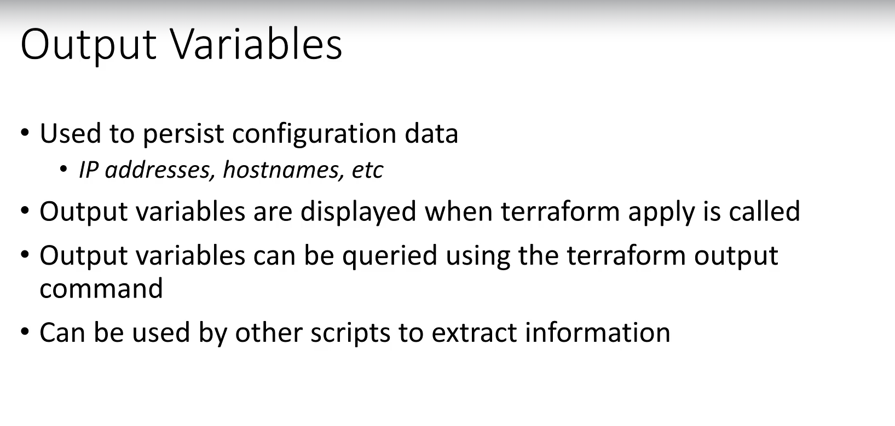

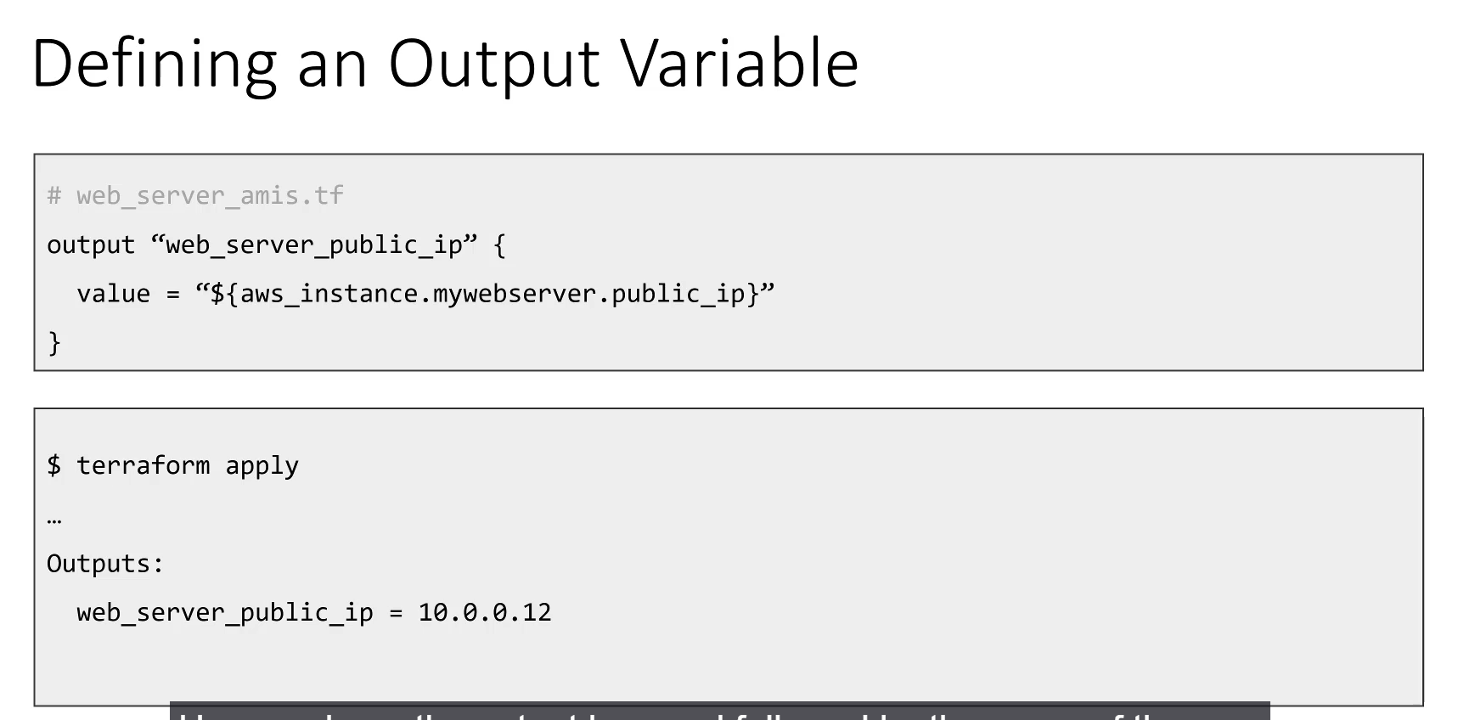

**==================================================================================**

* 1. **Interpolations**

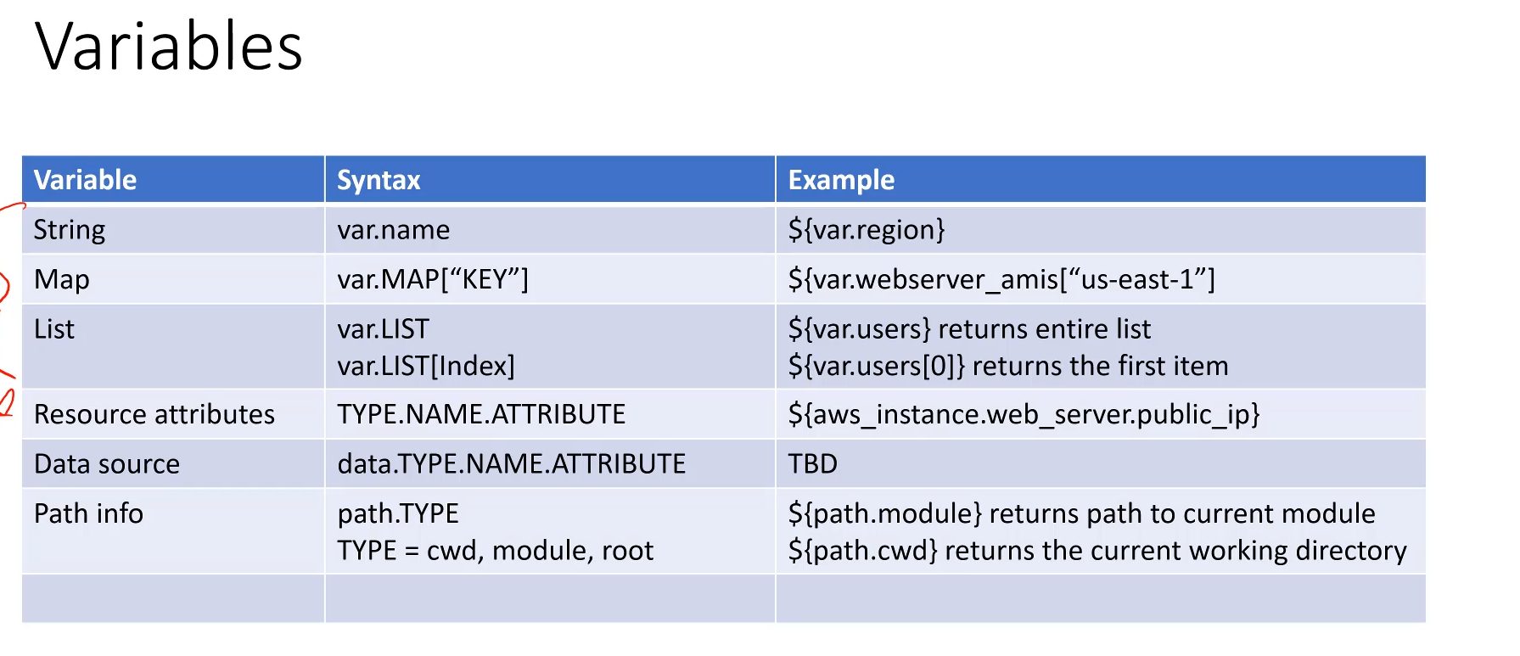

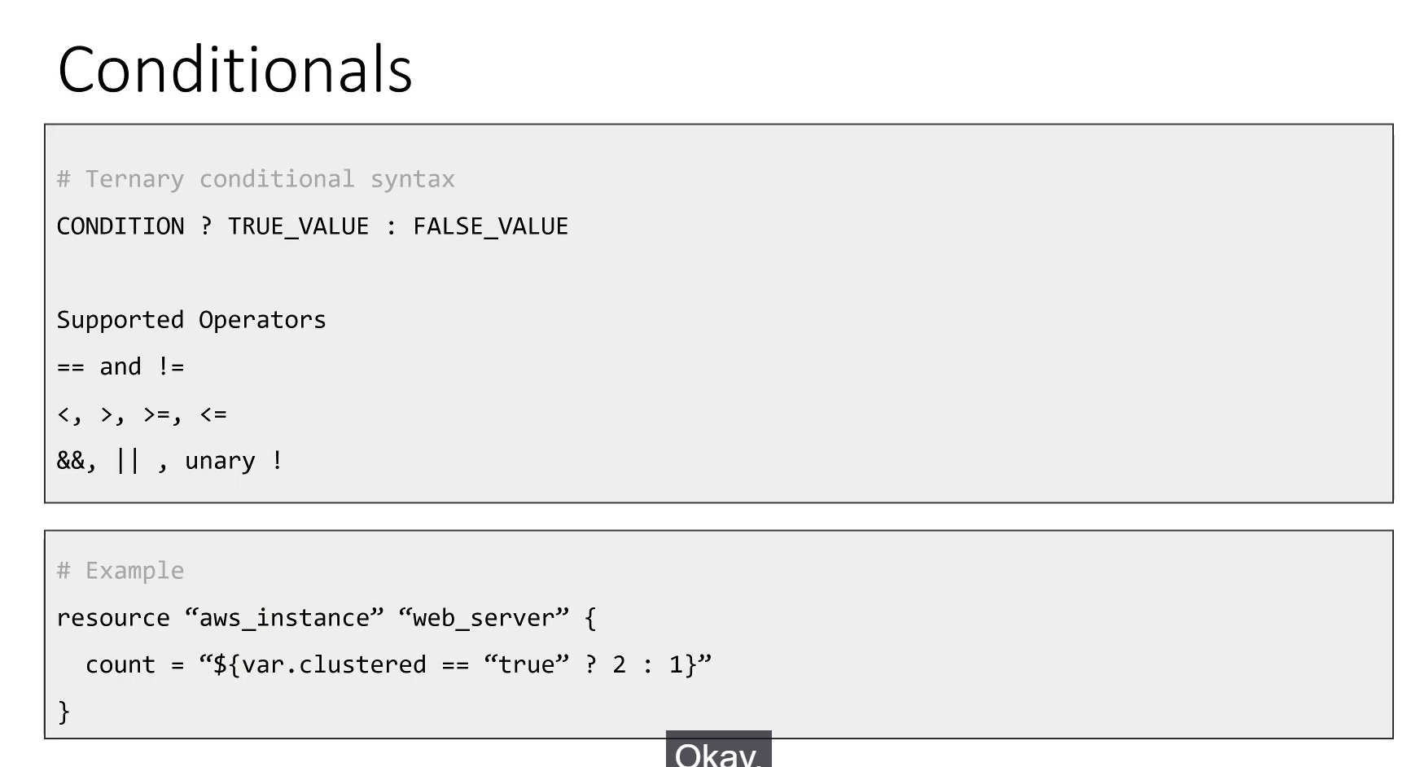

**Interpolations and Advanced Syntax**

Interpolations are the mechanism used to reference or calculate values within Terraform configurations. The general syntax for interpolation is ${...}.

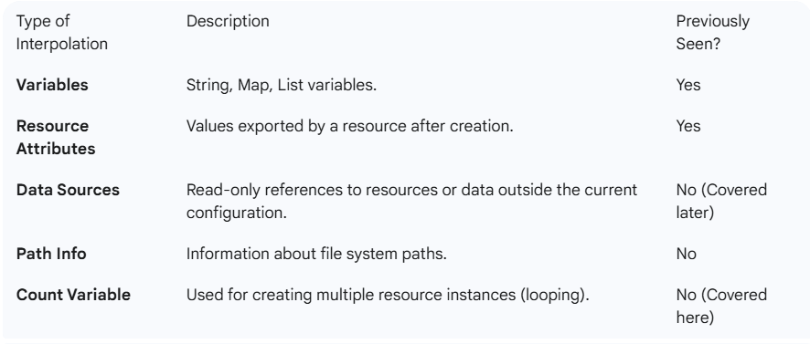

**1. Conditional Statements (Ternary Syntax)**

Terraform supports conditional logic within interpolations using the **ternary operator** for simple if-then-else scenarios.

* **Syntax:** CONDITION ? TRUE_VALUE : FALSE_VALUE
* **How it Works:**
  1. The CONDITION is evaluated (e.g., is a variable true?).
  2. If the condition is true, the entire statement returns the TRUE_VALUE.
  3. If the condition is false, the entire statement returns the FALSE_VALUE.
* **Example Use Case:** To conditionally set the number of servers to create based on a flag:

count = "${var.clustered == "true" ? 2 : 1}"

* •

If clustered is true, the count will be 2.

* If clustered is false, the count will be 1.

• **Supported Operators:** Equality (==), inequality (!=), less than (<), greater than (>), greater than or equal to (>=), less than or equal to (<=), and binary/bitwise operators.

**2. Built-in Functions**

Terraform includes a wide array of built-in functions for data manipulation, calculations, and utility tasks. Functions are always used inside interpolation syntax.

* **Syntax:** ${function_name(arg1, arg2, ...)}
* **Function Categories:** List, Map, CIDR calculations, Math, String formatting, and Hashing algorithms.
* **Examples:**
  + file(): Loads a file's content into a string.
  + lookup(): Retrieves a value from a map based on a provided key.
  + cidrnetmask(): Computes a netmask based on an IP range.

<hr>

**3. Templates and Data Sources**

Templates are used to parameterize long strings of text or external configuration files, substituting placeholders with interpolated values. They are treated as a **data source**.

* **Data Sources:** Used to read-only views of resources or components that exist outside of your current Terraform configuration.
* **template_file Data Source (Example):**
  + Defines a template either **inline** or by referencing an external **file on disk**.
  + It contains placeholders (e.g., ${username}, ${public_key}).
  + The **vars** attribute is used to explicitly specify the map of variables whose values will replace the placeholders.
* **Rendering the Template:** The final, processed string is retrieved using the **.rendered** attribute in an output or resource block:

output "rendered_script" {

value = data.template_file.inline_example.rendered

}

**4. Resource Repetition (count)**

The count attribute allows the creation of multiple identical instances of a single resource block.

* **Syntax:**

resource "aws_instance" "web_server" {

count = 2 # Creates two instances

# ... other attributes

}

• **Referencing Multiple Instances (count.index):**

* The count variable provides the **count.index** attribute, which is used for iteration.
* Inside the resource block, you can use ${count.index} as a key to look up values in a list or map, allowing each instance to receive a unique configuration (e.g., a unique private IP address).
* *Note:* Terraform manages this iteration implicitly; you don't write an explicit for loop.

• **Referencing a Specific Instance (Splat Syntax):**

* To access an attribute of a single, specific resource within the list created by count, use the **Splat (*) operator** followed by an index.
* **Syntax:** RESOURCE_TYPE.RESOURCE_NAME[*].ATTRIBUTE[INDEX_VALUE]
* *Example:* aws_instance.web_server.*.private_ip[0] requests the private IP address of the **first** web server instance (since indexing starts at 0).

**5. Basic Math Functions**

Terraform supports basic mathematical operations directly in the code for simple calculations:

* **Operations:** Addition (+), subtraction (-), multiplication (*), division (/), and modulo (%).
* *Example:* Used within interpolations, often to calculate values based on other variables or attributes.

******************************************************************************************************************************************************************************************************************************************************************************************

**Section 4: Resources Dependencies:**

1. **Resources Dependencies:**

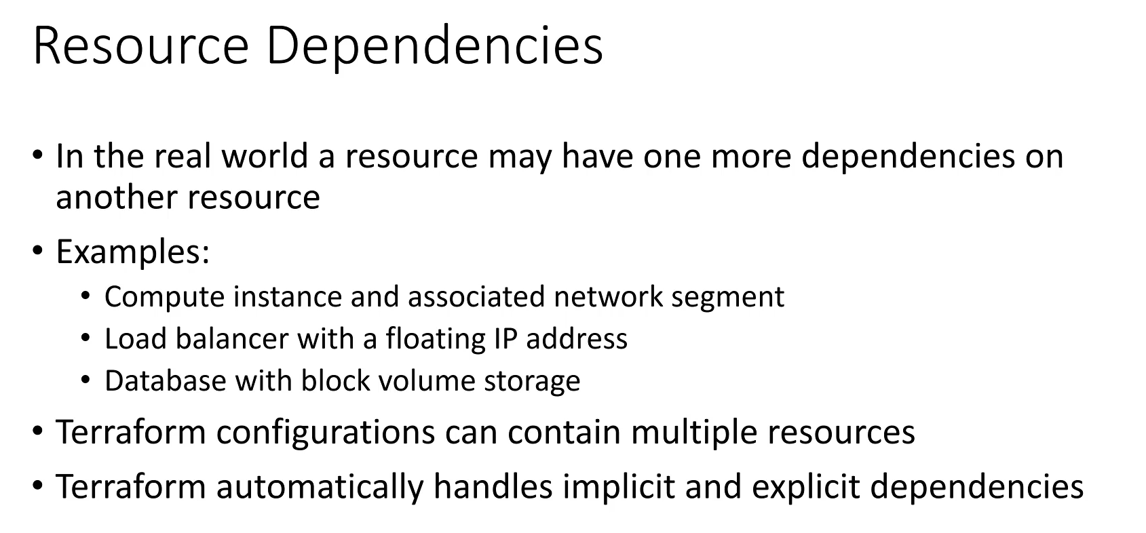

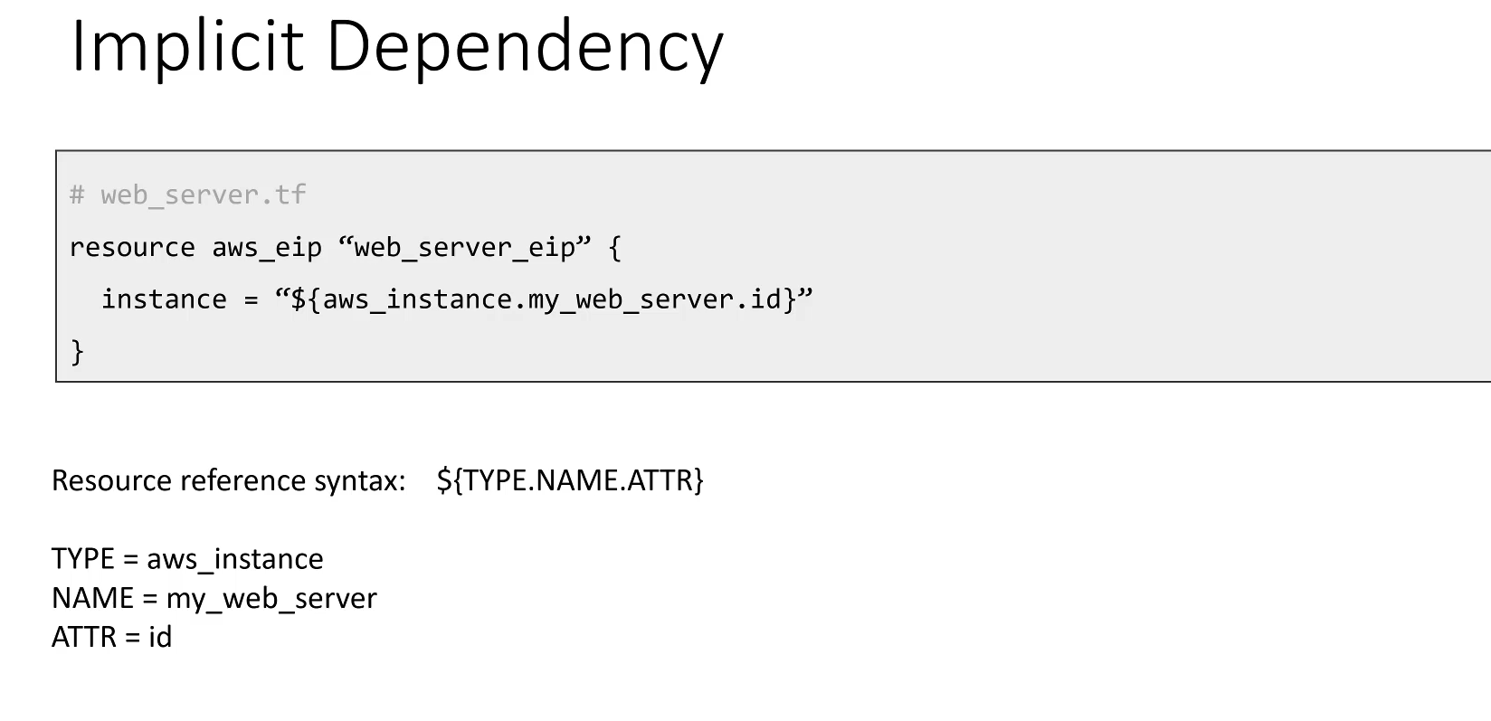

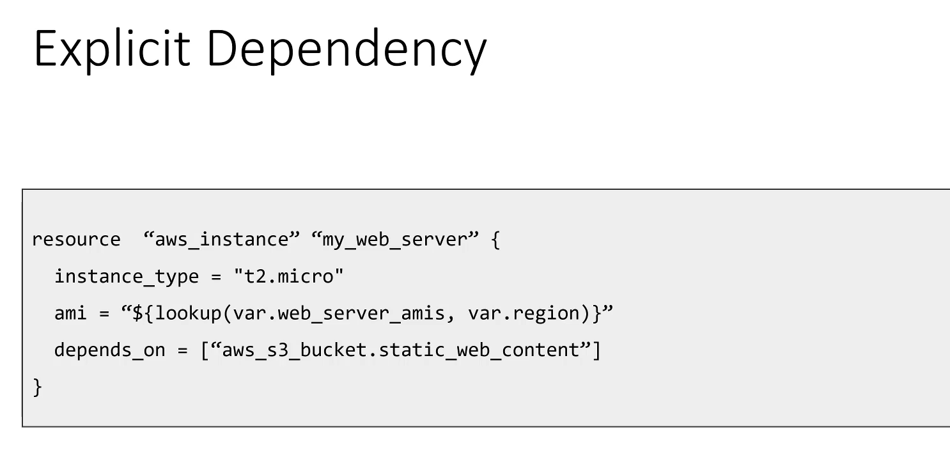

**Resource Dependencies in Terraform**

In real-world infrastructure, resources often rely on others being created first (e.g., a VM needs a subnet, a load balancer needs a floating IP, a database needs storage). Terraform handles this ordering automatically.

**Terraform's Dependency Graph**

* Terraform automatically constructs a **dependency graph** from your configuration code.
* This graph identifies all relationships, whether they are **implicit** (derived from the code) or **explicit** (manually defined).
* **Parallelization:** Resources with no dependencies on each other are created **in parallel**, significantly speeding up deployment.
* **Ordering:** Resources that *do* have dependencies are provisioned in the **correct sequential order**, ensuring prerequisites are met.

**1. Implicit Dependencies**

An implicit dependency occurs when one resource references an attribute of another resource. Terraform automatically detects this reference and sets the creation order.

* **Mechanism:** Resource A uses an output attribute (like an ID or an address) from Resource B as one of its input values.
* **Reference Syntax:** The standard way to reference another resource is:

RESOURCE_TYPE.RESOURCE_NAME.ATTRIBUTE

**Example (Elastic IP on a Compute Instance):**

resource "aws_eip" "web_server_ip" {

# The 'instance' attribute requires the ID of the compute instance

instance = aws_instance.my_web_server.id

}

• **Dependency:** The aws_eip resource needs the id of the aws_instance.my_web_server.

• **Terraform Action:** Terraform will **implicitly** ensure that the my_web_server compute instance is created **first**, and only then will it create the web_server_ip Elastic IP and associate it.

**2. Explicit Dependencies**

An explicit dependency is a direct instruction, used as a fallback when no implicit reference exists, but an ordering is still required (e.g., to ensure a certain action happens before a resource is created).

* **Mechanism:** You manually add the **depends_on** meta-argument to a resource block.
* **Use Case:** Typically used when a resource needs another resource to exist, but it doesn't use any of that resource's *output attributes* in its own configuration.

**Syntax:**

resource "aws_instance" "my_web_server" {

# ... other attributes ...

depends_on = [

aws_s3_bucket.my_storage_bucket

]

}

• **Dependency:** The my_web_server is explicitly stated to be dependent on the my_storage_bucket.

• **Terraform Action:** Terraform will **explicitly** ensure the aws_s3_bucket.my_storage_bucket is created **first**, followed by the aws_instance.my_web_server.

******************************************************************************************************************************************************************************************************************************************************************************************

**Section 5: Terraform Provisioners:**

1. **Terraform Provisioners:**

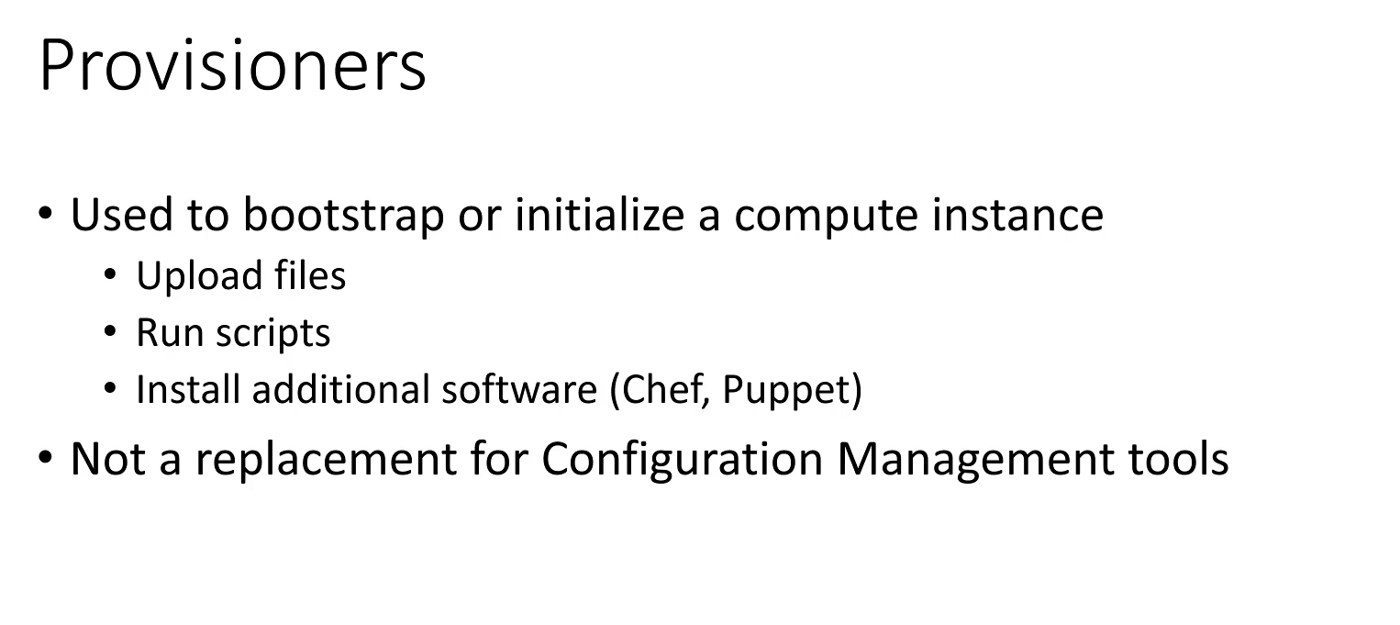

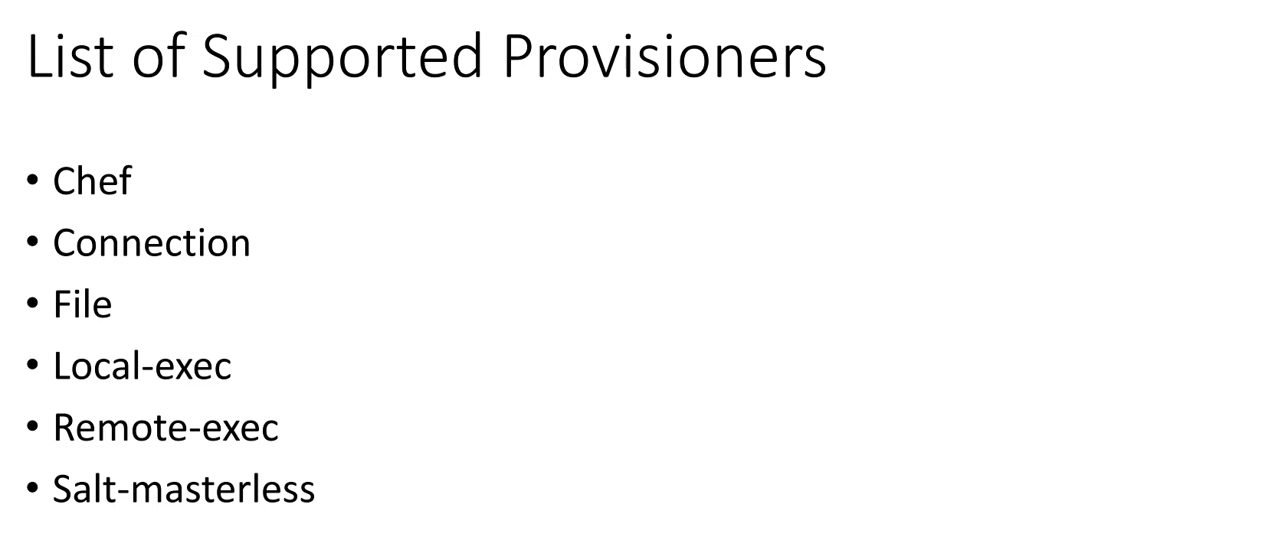

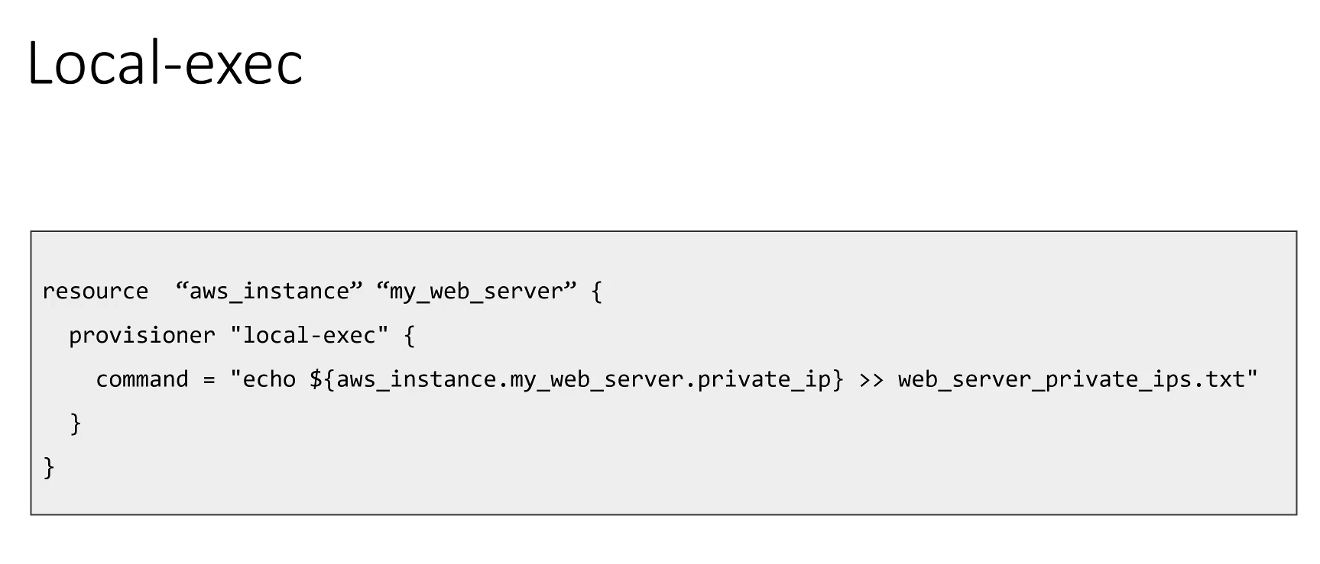

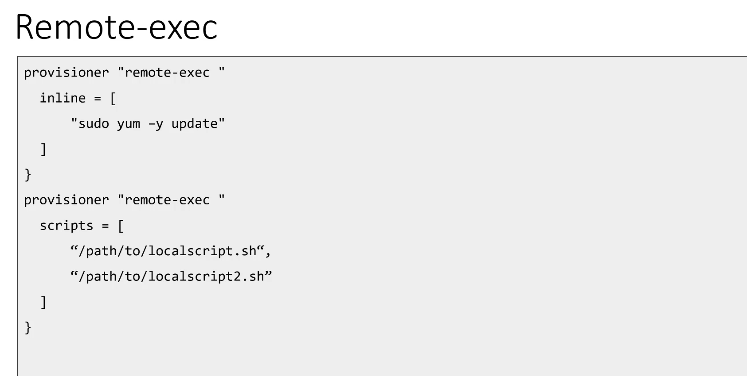

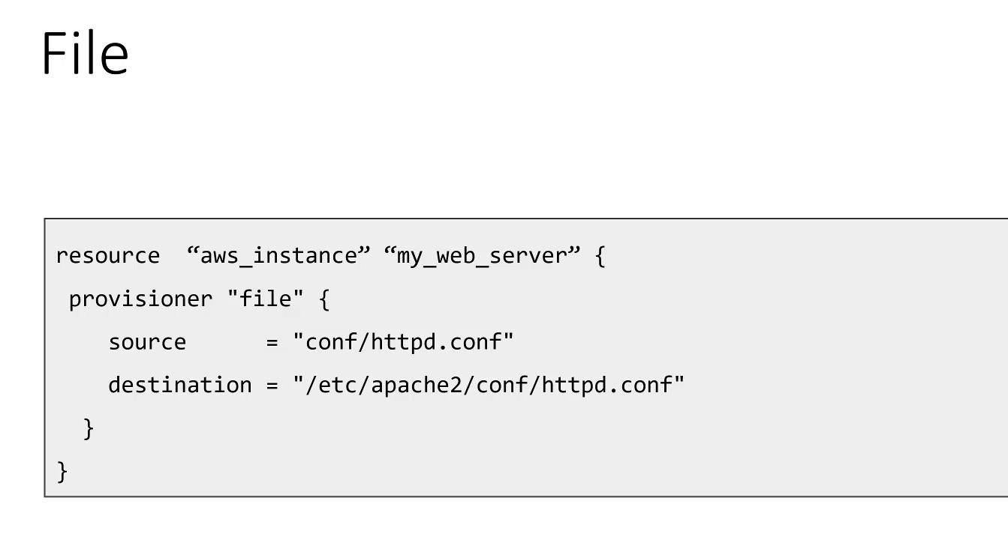

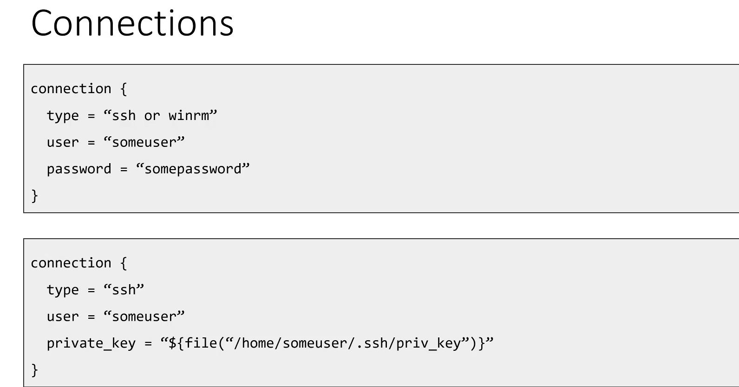

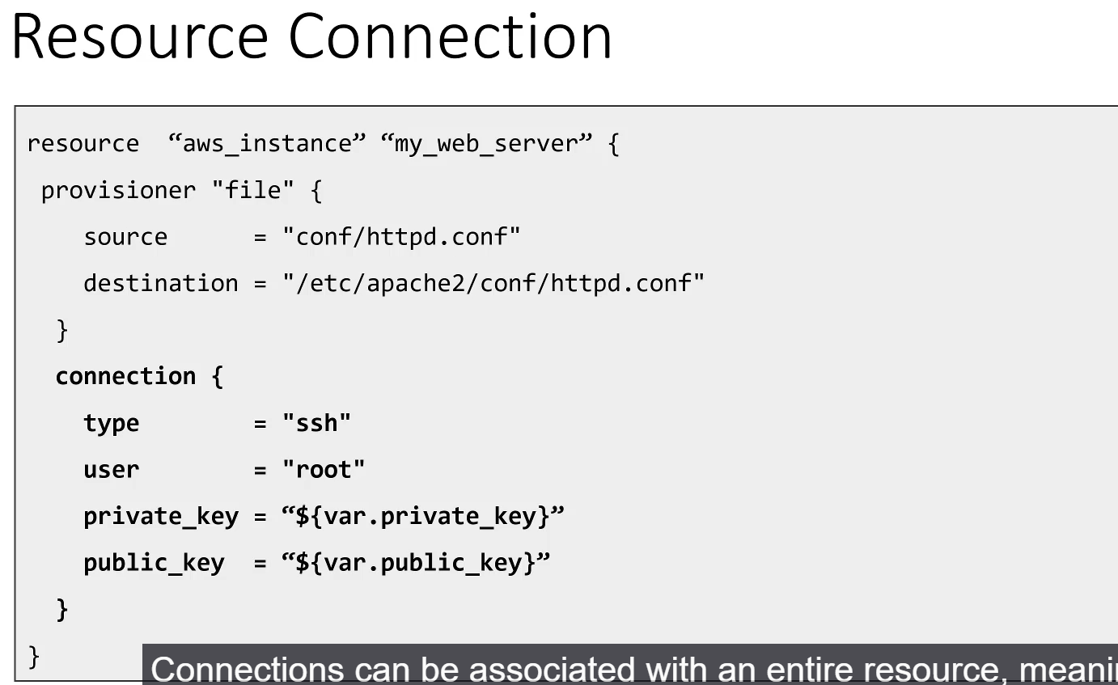

**TerraForm Provisioners**

**Provisioners** are mechanisms used to perform initial configuration or bootstrapping tasks on a resource *after* it has been created by Terraform. They typically involve running scripts or installing agents.

* **Primary Purpose:** To support the **initial bootstrapping** of a resource. In a production environment, a provisioner might install an agent (like a Chef or Puppet client), which then takes over the ongoing configuration management of the node.

**1. Types of Provisioners**

Terraform supports a variety of provisioner types:

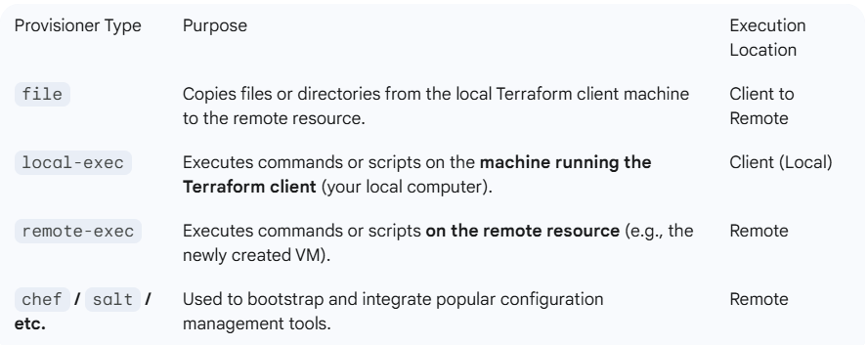

**2. Provisioner Syntax**

Provisioners are defined using a provisioner block nested **inside** the target resource block.

**A. local-exec Example:**

* This provisioner runs on the machine where you execute terraform apply.
* *Example:* Running a shell command to write the remote resource's private IP address to a local text file.

**B. remote-exec Example:**

* Allows running commands directly on the new remote resource.
* **Inline Commands:** Fine for a few simple commands.
* **Scripts:** For more complex tasks, you can supply a shell script. The provisioner will upload the script to the remote host and then execute it.

**C. file Example:**

* Used for staging configuration files (like an Apache config) or setup scripts.
* Requires two main attributes:
  + source: Path to the file on the **local client machine**.
  + destination: Path where the file should be copied **on the remote resource**.

**3. Configuring the Connection**

To perform remote operations (like copying files or running scripts), Terraform needs to know how to log into the remote resource. This is defined using a **connection** block.

* **Placement:** A connection block can be defined:
  1. **At the Resource Level:** Applied to the entire resource, meaning all provisioners within that resource will use the same connection settings.
  2. **At the Provisioner Level:** Scoped to a specific provisioner block, allowing different provisioners to connect using different credentials (e.g., connecting as root first to create user accounts, then reconnecting as a non-privileged user to install software for security).
* **Supported Connection Methods:**
  1. **SSH:** Requires a user and either a password or a private_key. (Most common for Linux/Unix systems).
  2. **WinRM:** Used for connecting to Windows-based resources.
* **Example (SSH with Private Key):**

resource "aws_instance" "example" {

# ... resource attributes ...

connection {

type = "ssh"

user = "ec2-user"

private_key = file("~/.ssh/my-key.pem")

}

# ... provisioner blocks ...

}

===================================================================================

1. Creating an SSH Key Pair:

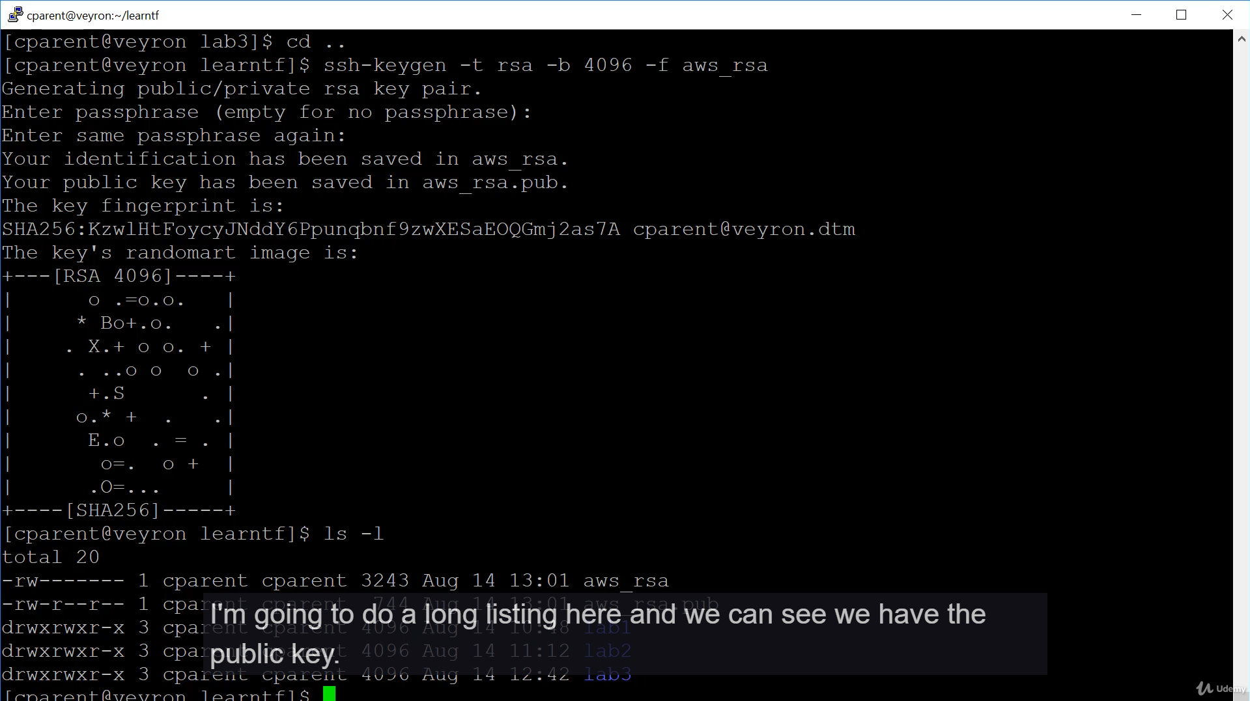

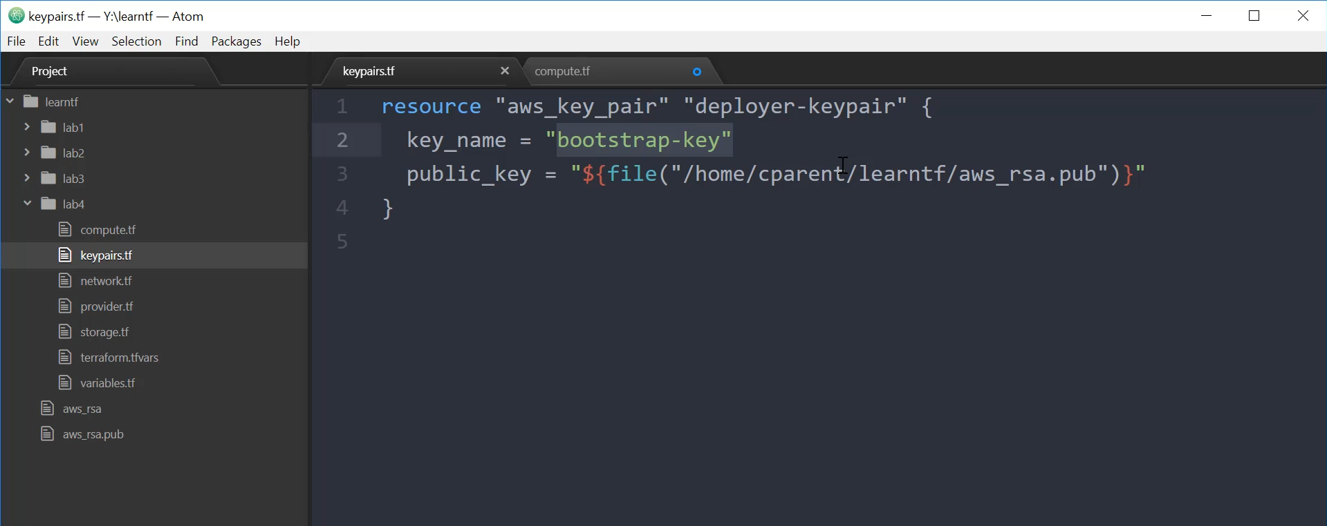

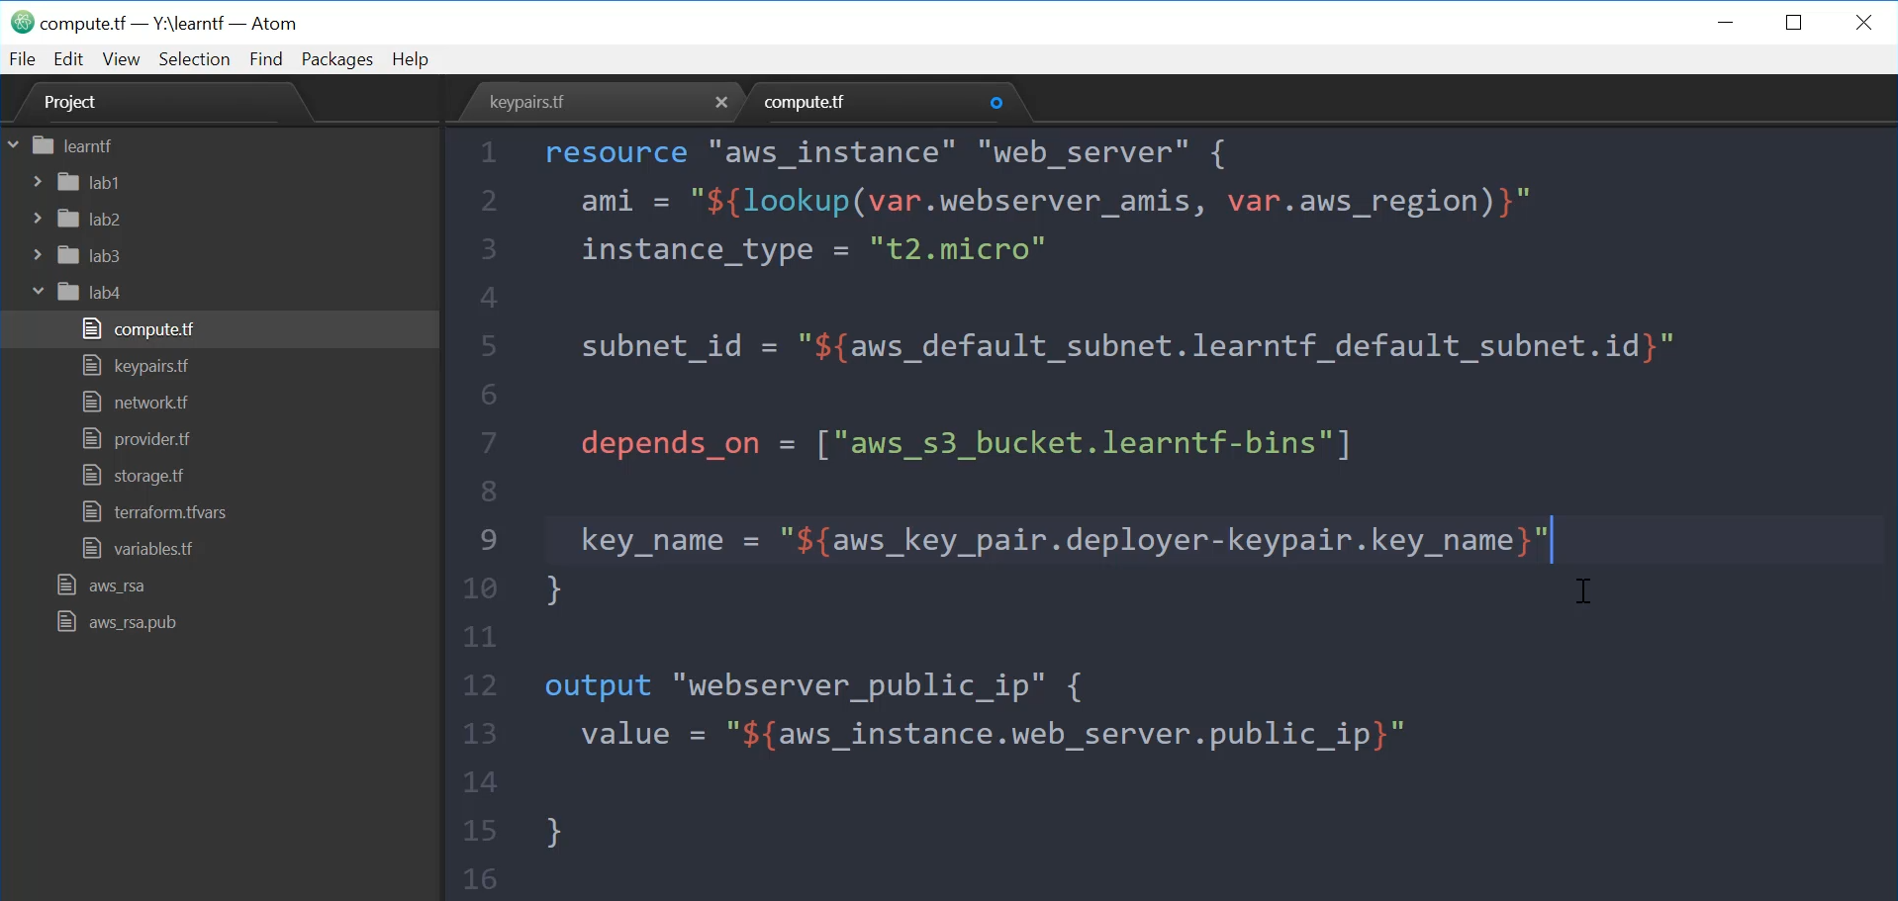

===================================================================================

1. Allowing SSH Traffic:

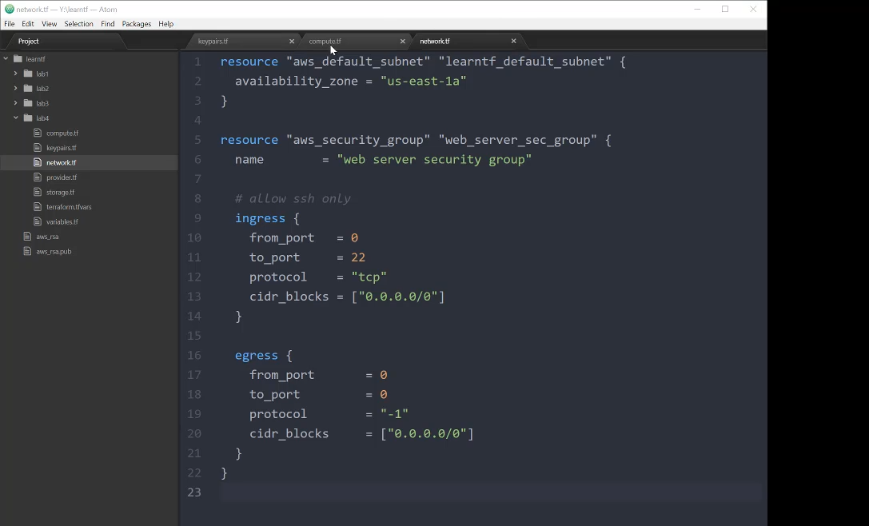

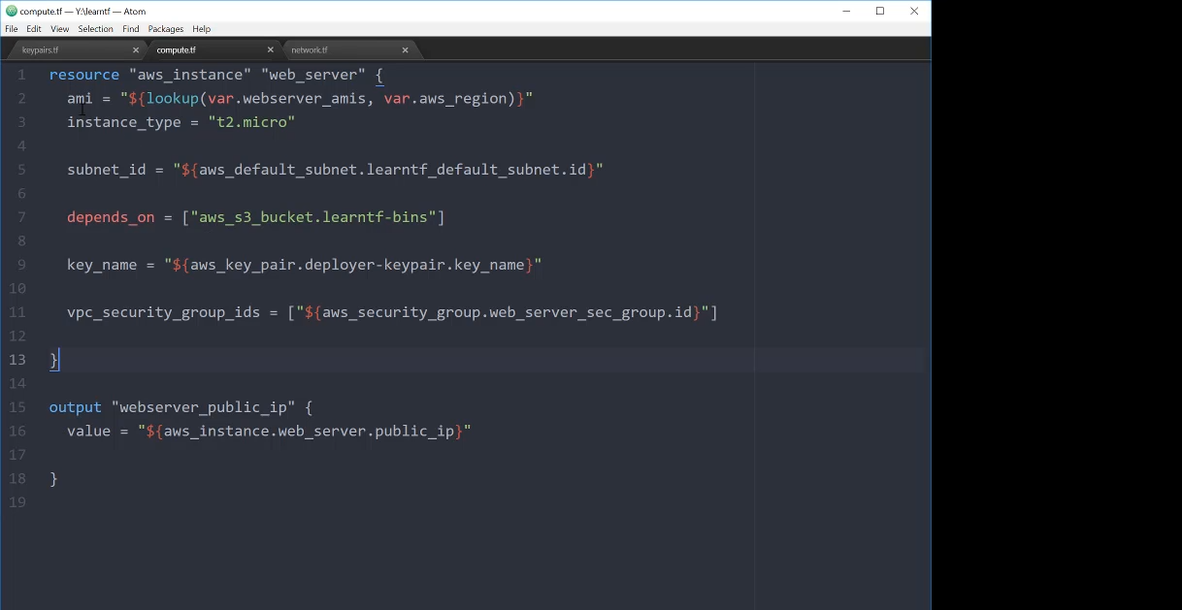

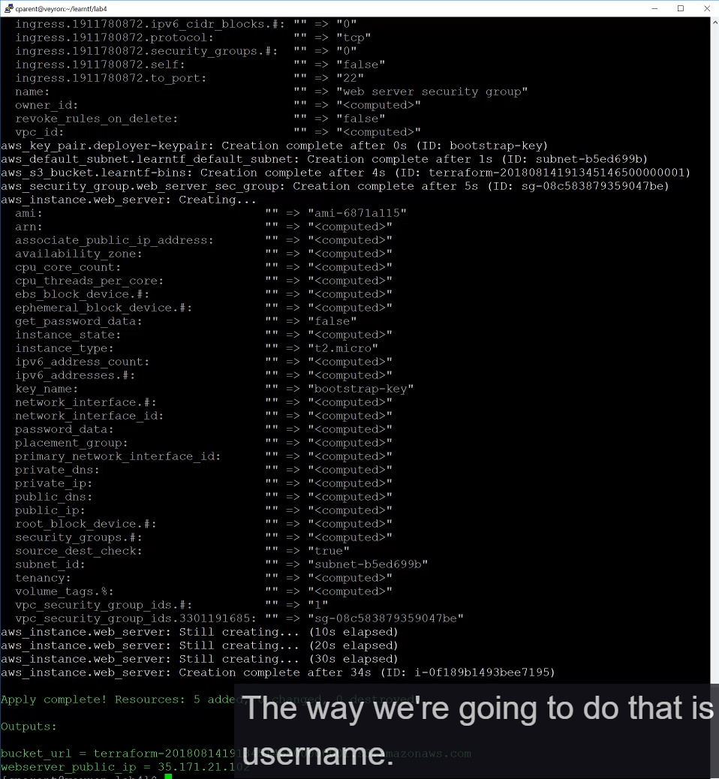

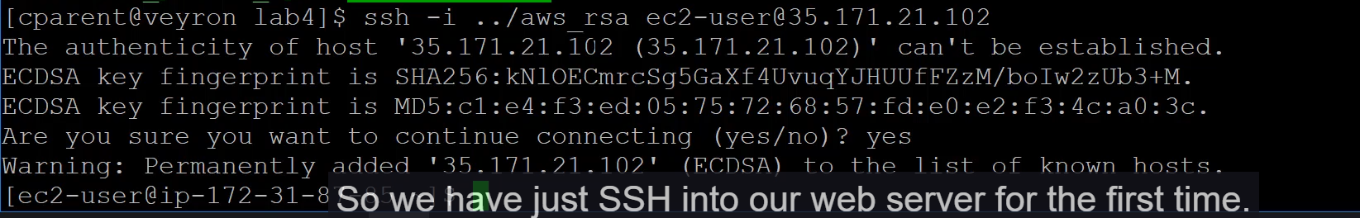

===================================================================================

1. Installing Apache by provisioner:

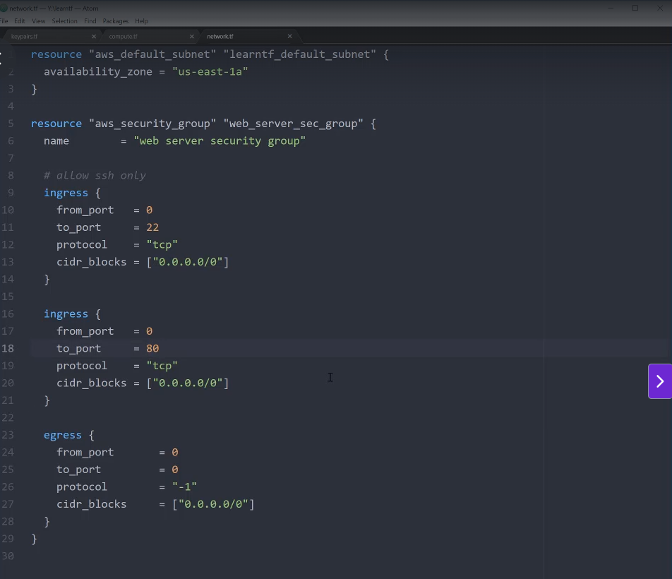

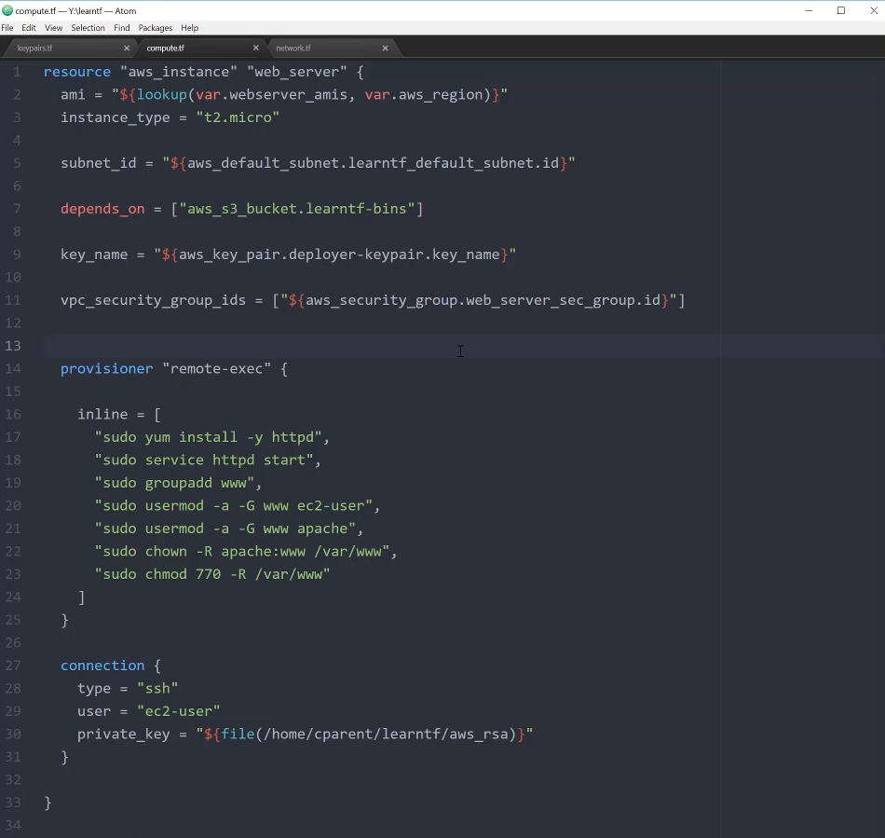

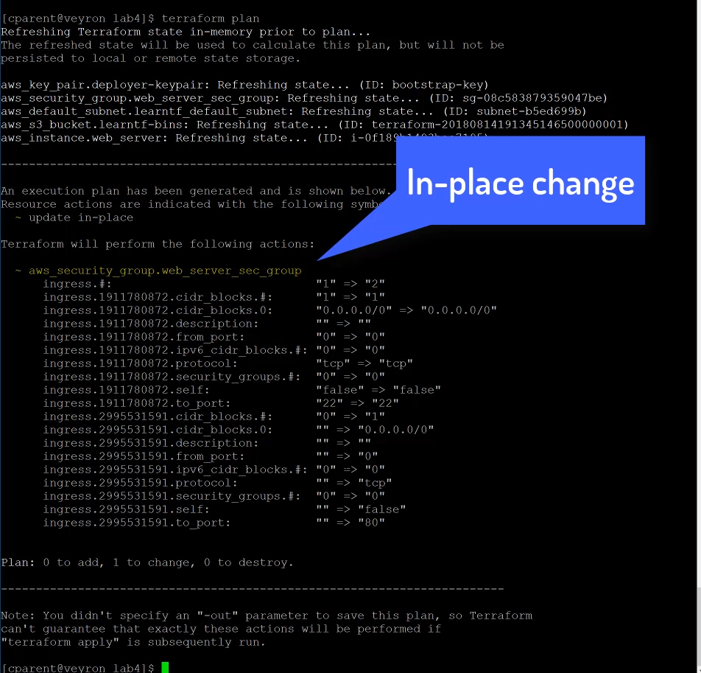

Terraform apply command:

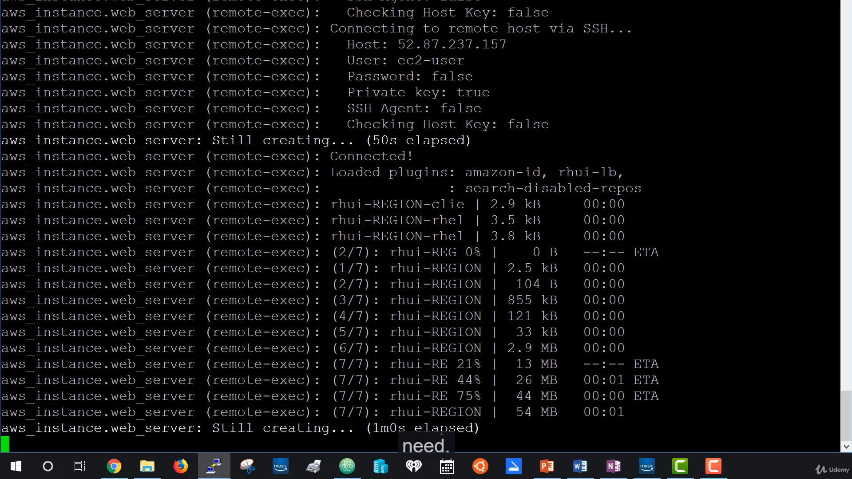

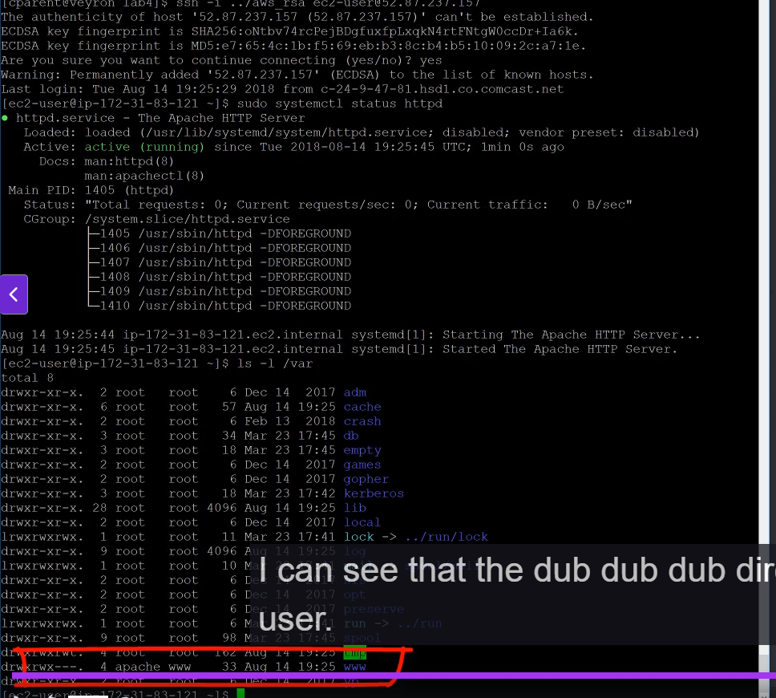

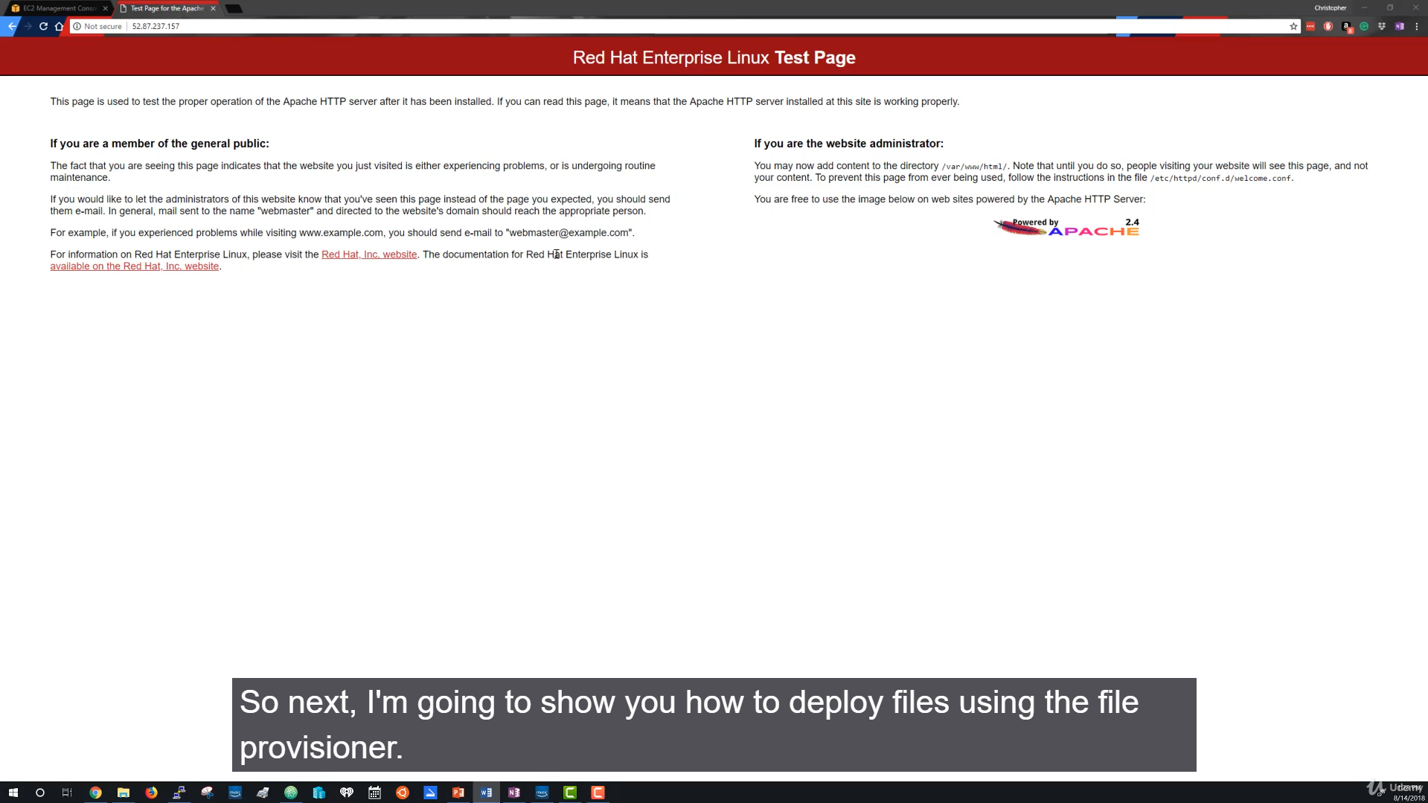

===================================================================================

1. Uploading file using a file provisioner:

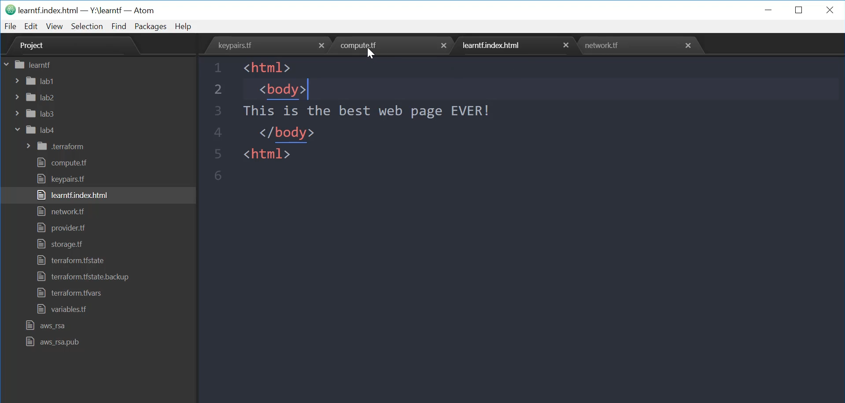

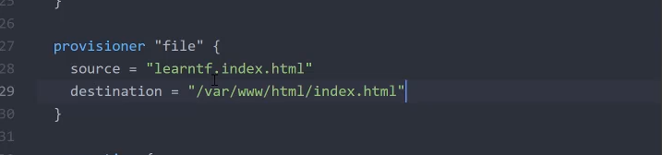

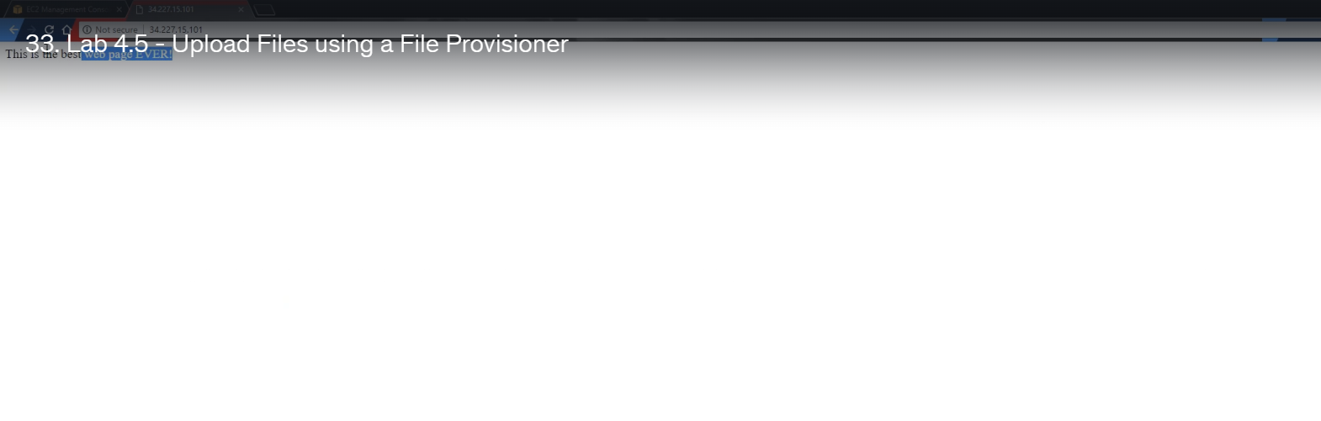

===================================================================================

1. Using an External script with a Remote execution provisioner:

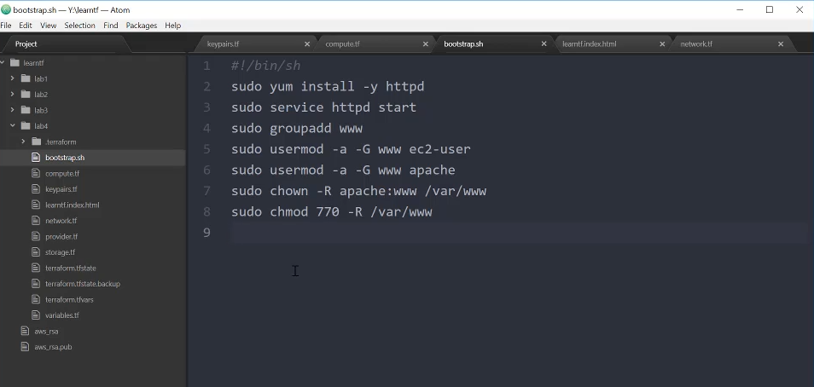

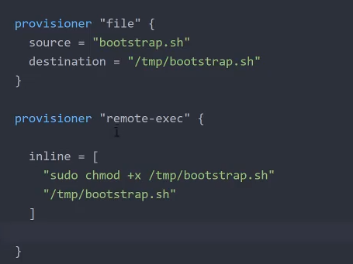

********************************************************************************************************************************************************************************************

**Section 6: Terraform Data Sources:**

1. **Terraform Data Sources:**

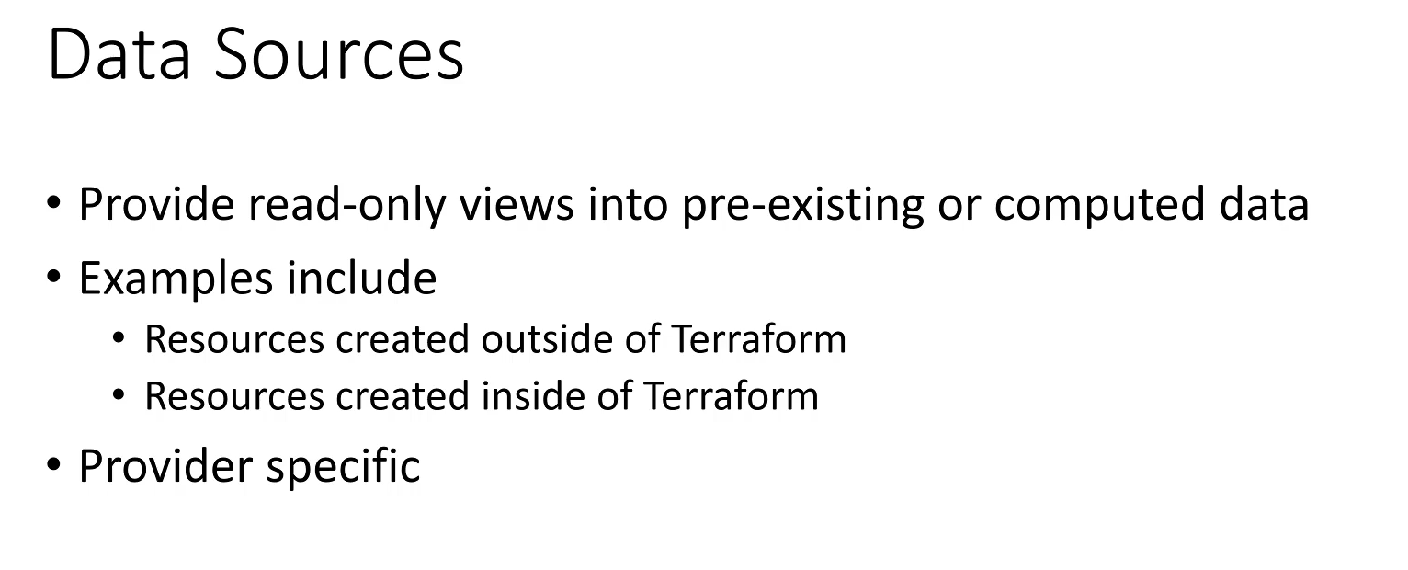

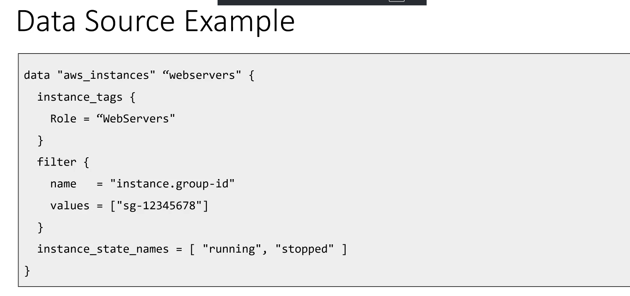

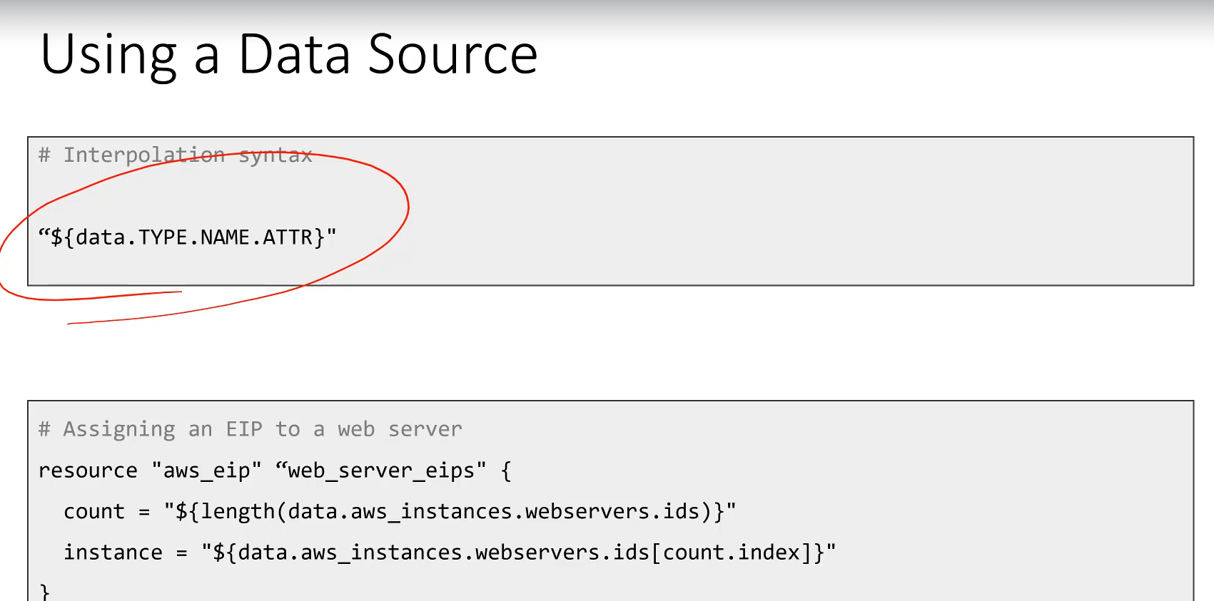

This lecture introduces **Terraform Data Sources**, explaining their purpose as a way to retrieve and use existing data or infrastructure outside the current configuration.

**TerraForm Data Sources**

**1. Purpose of Data Sources**

* **Data Retrieval:** Data sources allow you to **fetch or compute data** to be used elsewhere in your Terraform configuration.
* **External Information:** They are the mechanism to build configurations based on information that **exists outside** of the current Terraform code.
* **Examples:** A data source can fetch:
  + A list of available **Amazon Machine Images (AMIs)**.
  + A list of existing or filtered resources (e.g., compute instances that were created manually or by another Terraform configuration).
* **Provider-Specific:** Like resource types, data sources are specific to a particular Terraform Provider (e.g., AWS, GCP, Azure).

**2. Data Source Definition Syntax**

A data source block is used to define the criteria for what information you want to retrieve.

**Syntax:**

data "DATA_SOURCE_TYPE" "NAME" {

# Filtering and configuration attributes

}

* **data Keyword:** The required keyword to start the block, signaling a data retrieval operation.
* **DATA_SOURCE_TYPE:** The type of information to retrieve (e.g., aws_instances).
* **NAME:** An arbitrary name you assign to this specific data source block (e.g., web_servers).
* **Attributes (Filtering):** The contents inside the block specify the search criteria.
  + *Example:* An aws_instances data source can be configured to filter for instances tagged as "web servers" that are in a "running" or "stopped" state, and have a specific group ID.
* **Terraform Action:** When executed, Terraform connects to the configured provider (e.g., AWS) and retrieves the list of resources that match the specified criteria.

**3. Using a Data Source (Interpolation)**

Once a data source is defined, you can access the retrieved attributes (which are often lists of IDs or other values) using interpolation.

* **Interpolation Syntax:**
* data.DATA_SOURCE_TYPE.NAME.ATTRIBUTE
  + **data:** Indicates you are referencing a defined data source.
  + **DATA_SOURCE_TYPE & NAME:** Specify the exact data source block to query.
  + **ATTRIBUTE:** The specific attribute (e.g., a list of IDs, names, or IPs) you want to retrieve from the fetched data.
* **Example Use Case (Assigning IPs):** The retrieved list of web server instances can be used to control the creation of other resources.
  + The length() built-in function can determine the size of the list (how many web servers were found).
  + The count.index interpolation (from a previous lecture) can be used to iterate over the retrieved list and assign a new resource (like an Elastic IP address) to each discovered web server.

******************************************************************************************************************************************************************************************************************************************************************************************

**Section 7: Terraform Modules:**

1. **Terraform Modules:**

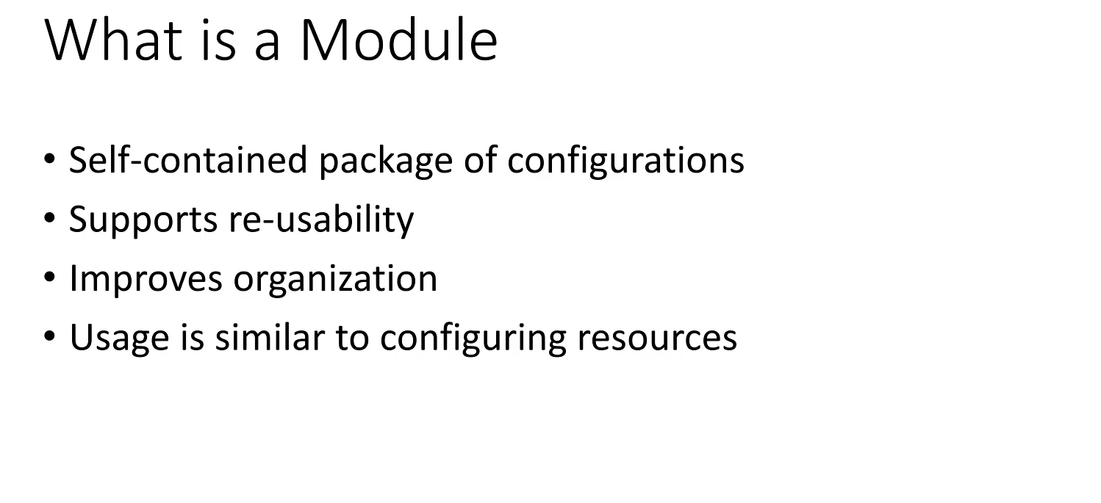

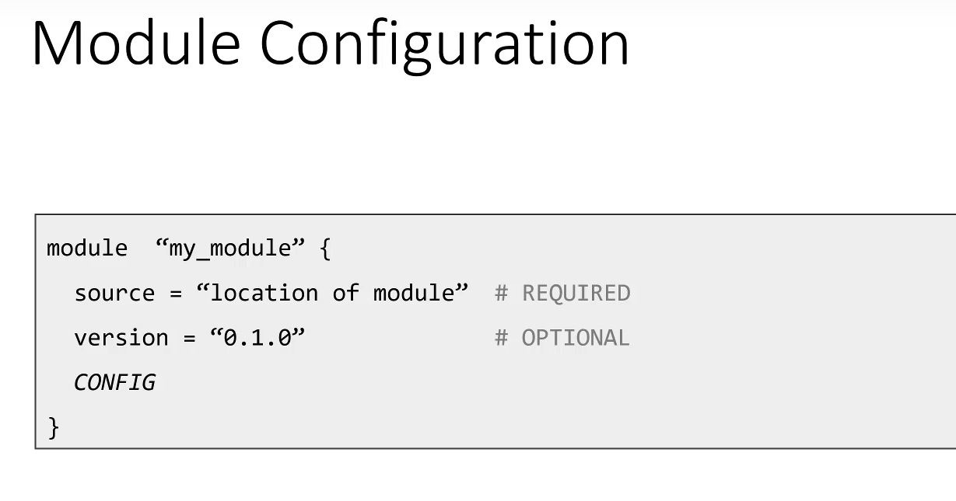

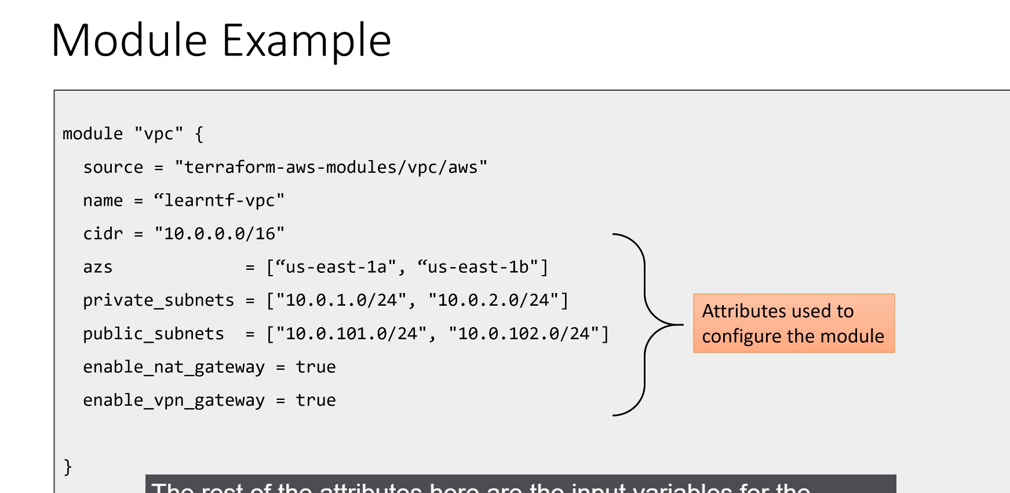

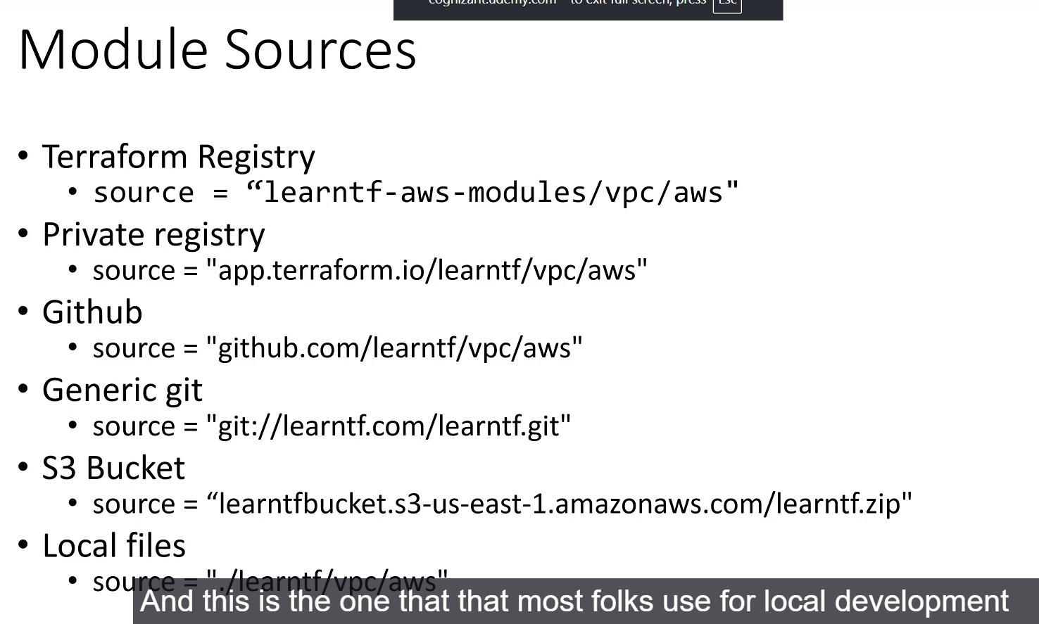

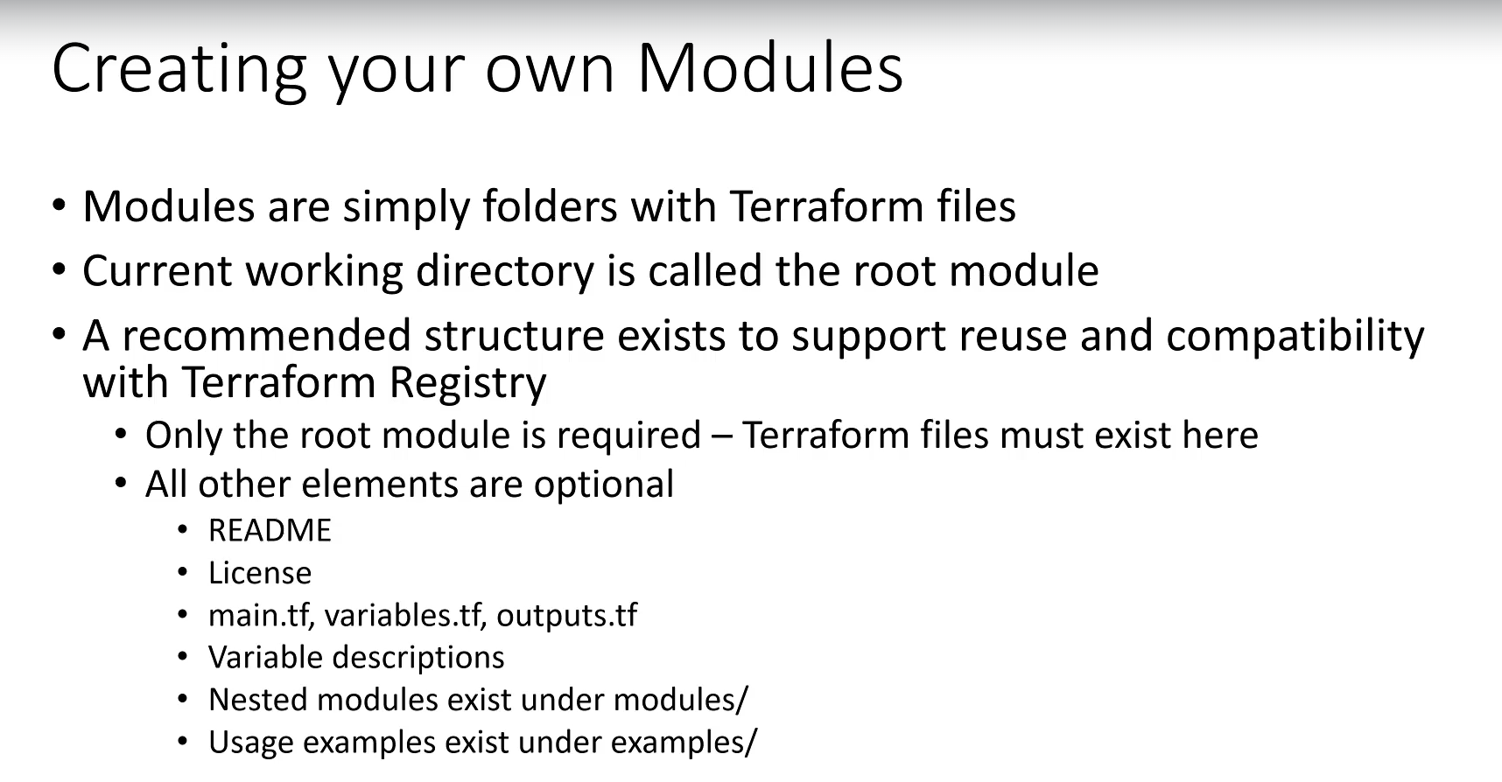

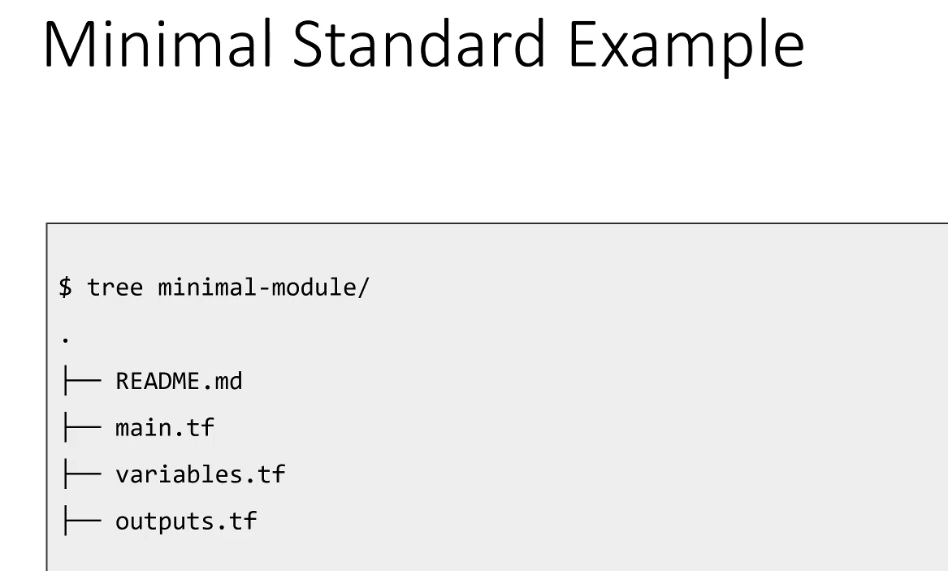

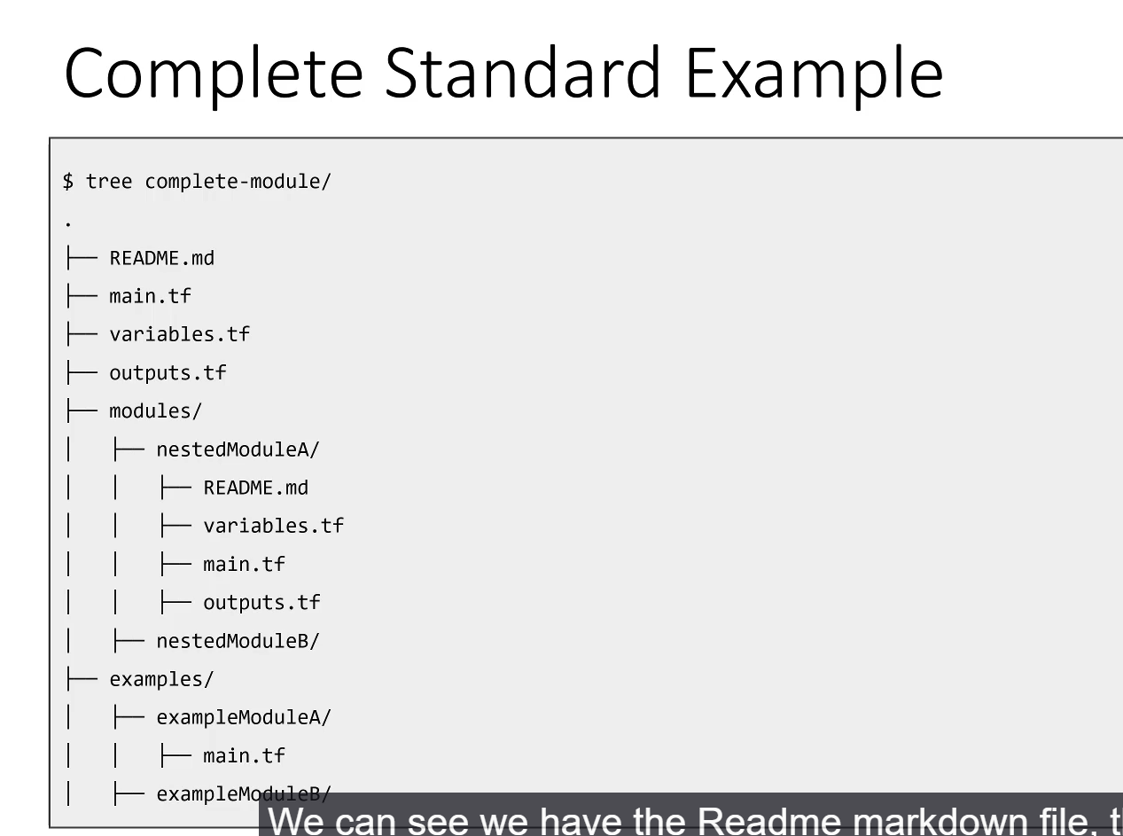

**TerraForm Modules**

**1. What Are Terraform Modules?**

A module is simply a **directory containing Terraform configuration files** (.tf files). They are self-contained packages designed to improve code organization and reusability.

* **Root Modules:** The main working directory where you execute Terraform commands is technically the **root module**.
* **Child Modules:** Any module referenced from within the root module or another module is a child module.

**2. Benefits and Use Cases**

* **Reusability:** A module allows you to package complex infrastructure (e.g., a complete 3-tier network) and reuse it across multiple projects or environments with minimal code.
  + *Example:* The **AWS VPC Module** can create over 25 resources (VPC, subnets, NAT Gateway, VPN Gateway) by only requiring a few input variables like a CIDR range.
* **Standardization:** Modules enable organizations to enforce standardized deployments.
  + *Example:* A security team can publish a "Network Perimeter Module" that ensures all new deployments conform to organizational security policies.
* **Organization:** They help manage large, complex configurations by breaking them down into smaller, logical units.

**3. Including and Configuring a Module**

Modules are included in a configuration using a module block:

module "my_module_name" {

source = "MODULE_SOURCE_ADDRESS"

version = "1.0.0" # Optional: Specifies a specific version

# Configuration/Input Variables for the module

input_var_1 = "value_1"

input_var_2 = "value_2"

}

* **module Keyword:** The required keyword to start the block.
* **my_module_name:** An arbitrary, local name used to reference the module's outputs or attributes within the calling configuration.
* **source Attribute (Crucial):** Tells Terraform what module to pull and **from where** it should be retrieved.
* **version Attribute (Recommended):** Allows you to pin the module to a specific release version, ensuring deployment consistency.
* **Configuration (input_var_*):** These are the **input variables** that the module itself defines. They are used to customize the module's behavior (e.g., CIDR ranges, availability zones).

**4. Supported Module Sources**

Terraform supports various locations for retrieving modules:

* **Terraform Registry:** A public repository (registry.terraform.io) where modules can be publicly shared. (e.g., hashicorp/vpc/aws).
* **Private Registry:** An organization-specific registry for internal modules.
* **Git Repositories:** Including **GitHub** and **GitLab**.
* **S3 Buckets:** Modules can be stored as archives in object storage.
* **Local File System:** Used for local development and testing, referencing a module in a relative path on your machine (e.g., ../modules/my_vpc).

**==================================================================================**

1. Using the AWS VPC module:

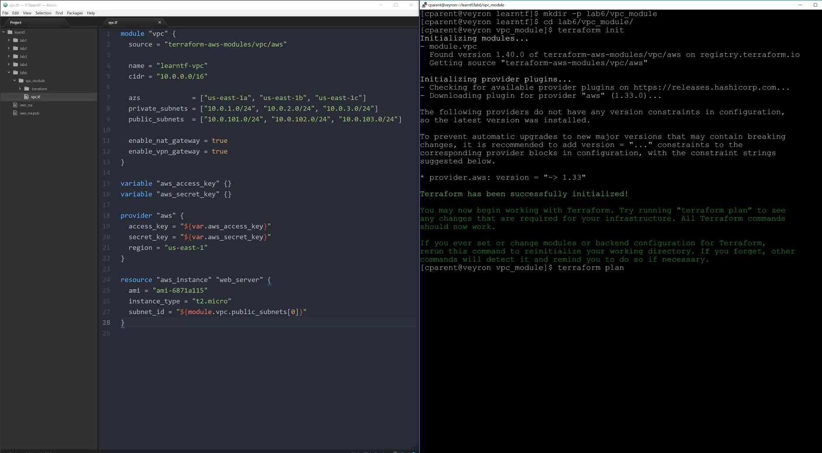

******************************************************************************************************************************************************************************************************************************************************************************************

**Section 8: Terraform States:**

1. **Terraform States:**

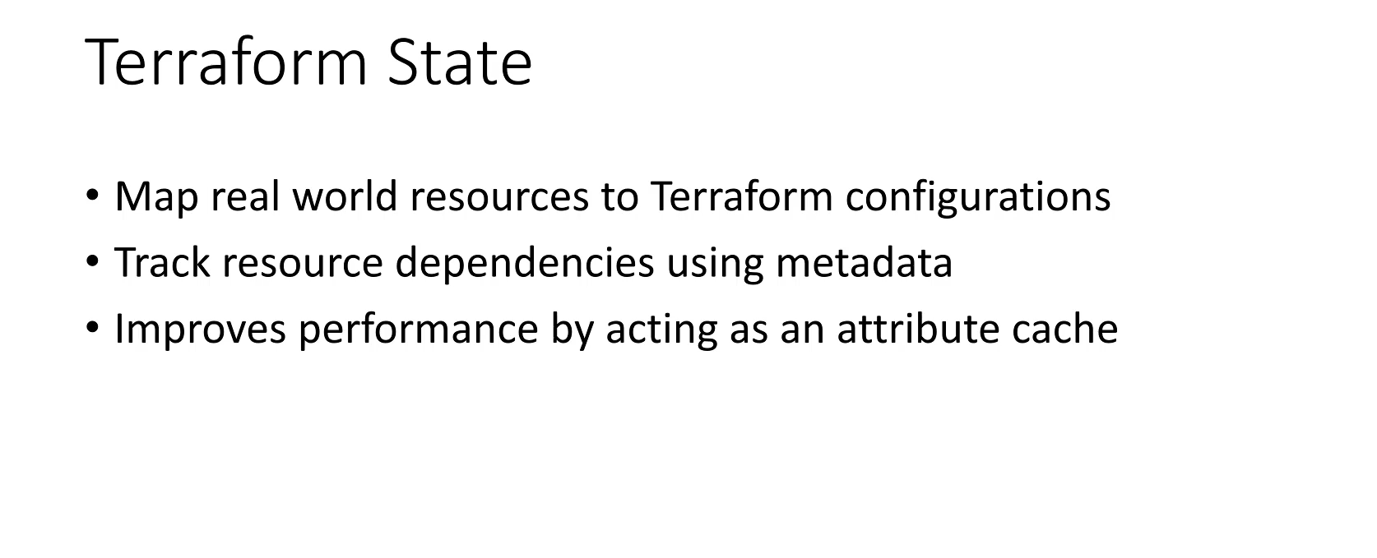

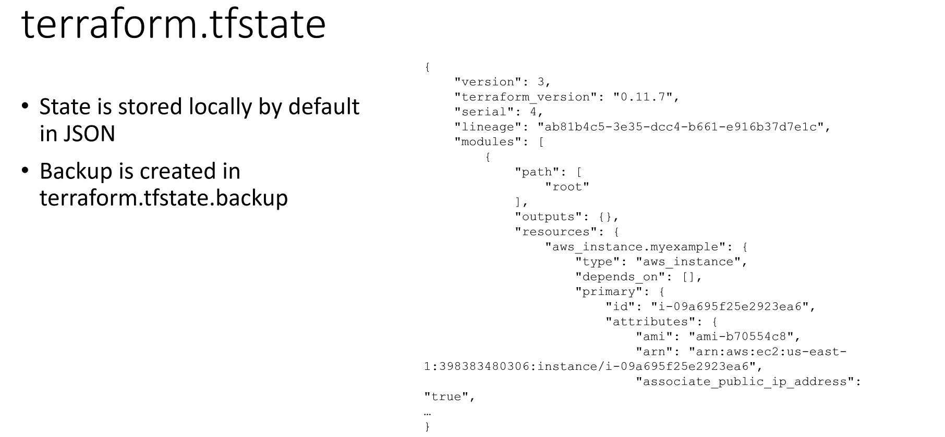

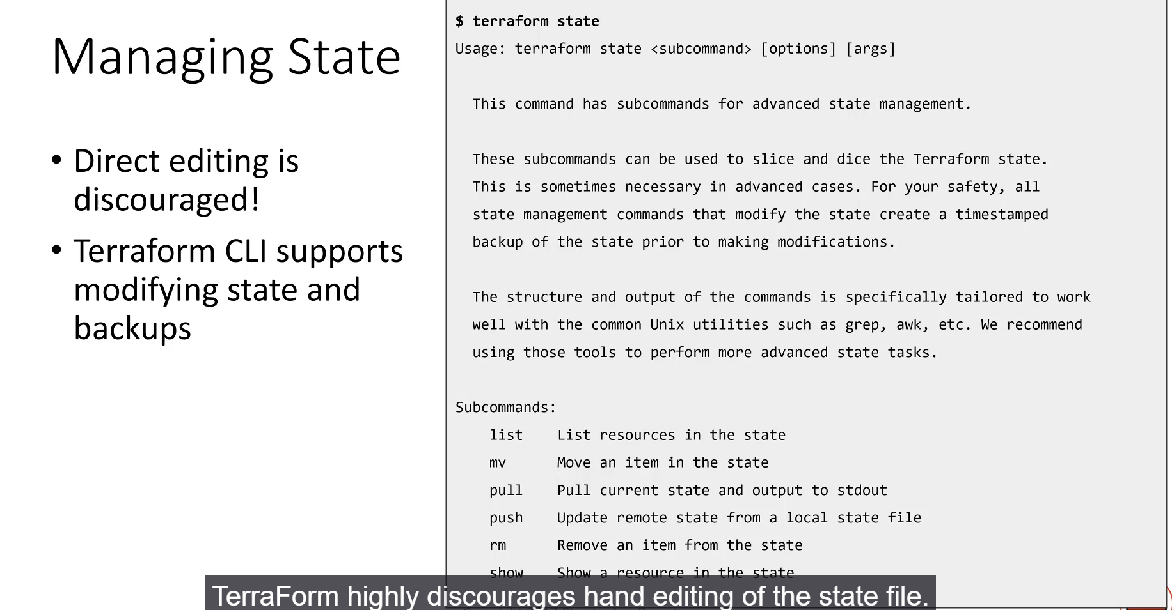

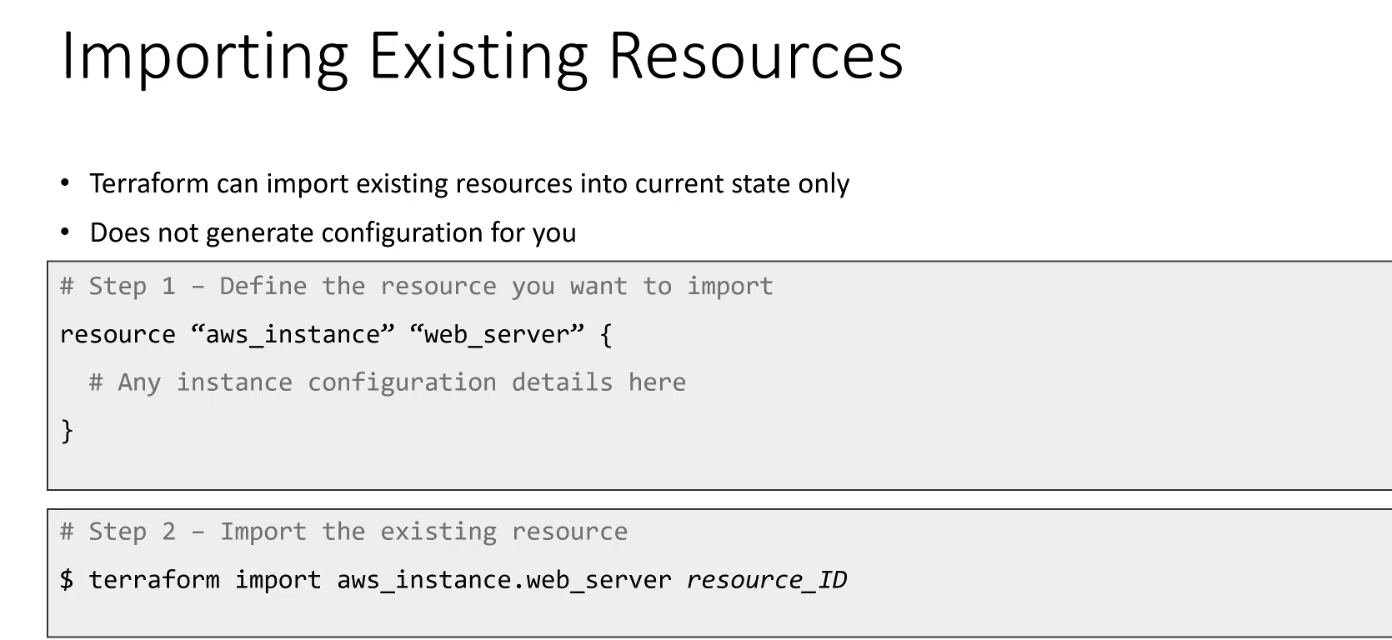

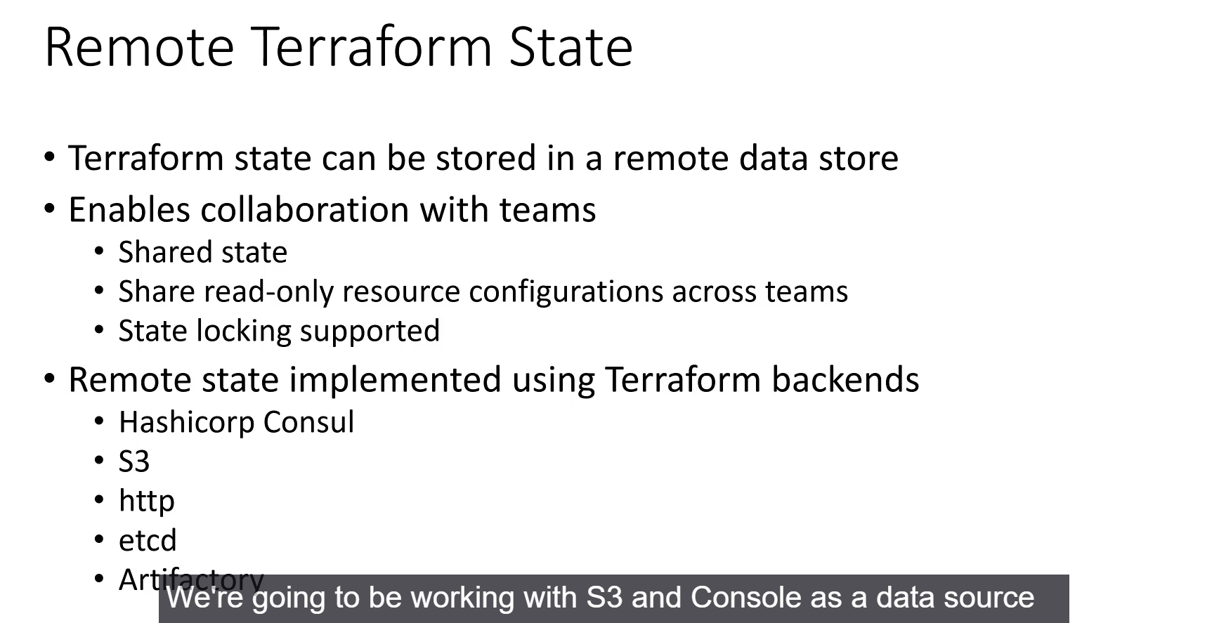

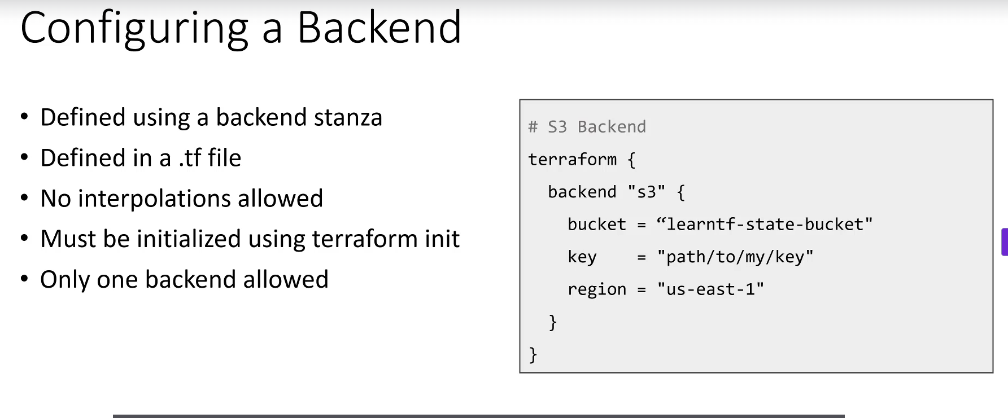

This lecture provides a detailed overview of **Terraform State**, covering its purpose, local versus remote storage, state management tools, and the process of importing existing infrastructure.

**TerraForm State Management**

**1. Purpose of the State File (terraform.tfstate)**

The state file is a crucial component that acts as the **source of truth** for Terraform, allowing it to understand the current reality of your infrastructure.

* **Resource Mapping:** It maps the resource names defined in your Terraform configuration code to the actual, real-world resources deployed in the cloud (e.g., matching aws_instance.web_server to a specific EC2 ID).
* **Dependency Tracking:** It tracks all dependencies between deployed resources, which is vital for planning updates and destructions in the correct order.
* **Performance Cache:** The state file serves as a cache for all resource attributes (e.g., IPs, IDs, names). This prevents Terraform from having to query the cloud provider for every resource attribute during every operation, significantly improving performance.
* **Format:** State files are saved in **JSON** format. Terraform also maintains a backup version (.tfstate.backup) during operations.

**2. Managing State Files**

Terraform strongly **discourages hand-editing** the state file due to the high risk of corruption, which could leave Terraform unable to manage your infrastructure.

* **terraform state CLI:** The official way to manipulate and manage state is using the terraform state command and its subcommands:
  + **list:** Lists resources in the state file.
  + **mv:** Moves an item (resource) within the state file.
  + **rm:** Removes a resource from the state file (without destroying the real-world resource).
  + **pull / push:** Used to retrieve state to standard output or update it from a local file, primarily for advanced scenarios.

**3. Importing Existing Resources**

Terraform can take ownership of resources created outside its configuration (e.g., manually via the console or by another tool).

1. **Define Configuration:** You must first manually create a matching **resource configuration** block in your .tf files for the existing resource.
2. **Run terraform import:** Execute the command, passing the name of the Terraform resource and the cloud provider's ID for the real-world resource.
   * *Example:* terraform import aws_instance.my_imported_server i-0a1b2c3d4e5f6g7h8
   * **Limitation:** As of this lecture, Terraform does not support importing resources in bulk or automatically generating configurations from existing resources.

**Remote State and Backends**

By default, state is stored **locally**. For collaborative development and production, **remote state** storage is the superior solution.

**Advantages of Remote State**

1. **Collaboration:** Enables multiple team members to work on the same infrastructure simultaneously, as they all reference a single source of truth for the current state.
2. **State Sharing (Read-Only):** One team (e.g., Networking) can build resources and expose their outputs (e.g., Subnet IDs) in a read-only manner, allowing another team (e.g., Compute) to easily consume them without needing an external data store like Consul.
3. **State Locking:** Many remote state data stores support **state locking**, which prevents concurrent terraform apply or destroy operations. This critical feature ensures only one write operation occurs at a time, preventing state file corruption.

**Supported Backends (Examples)**

Terraform supports numerous remote backends, including:

* **Amazon S3** (often paired with DynamoDB for locking)
* **HashiCorp Consul**
* **Azure Storage**
* **Google Cloud Storage**

**Configuring a Backend**

A backend is configured using the backend stanza, typically in the main.tf file.

**Syntax (Example with S3):**

terraform {

backend "s3" {

bucket = "my-remote-state-bucket"

key = "path/to/my/terraform.tfstate"

region = "us-east-1"

# Optional: enable state locking via DynamoDB

}

}

* **Key Restrictions:**
  1. **No Interpolations:** Interpolations (variables) are **not supported** within the backend stanza. Values must be hardcoded or loaded from a configuration file/command line during init.
  2. **One Backend:** Only **one backend** (local or remote) can be active at a time.

**The terraform init Command**

The terraform init command is essential when configuring or changing a backend:

* **Activation:** It activates the specified remote storage backend.
* **State Migration:** If a local state file exists when a remote backend is configured, terraform init will automatically handle the process of **moving (migrating)** the state file from local storage to the new remote location, and vice versa if you migrate back.

===================================================================================

2.Importing an pre existing resources into terraform:



